HM/TM L6
STRATEGIC LEADERSHIP

STRATEGIC LEADERSHIP
HM: New Zealand Diploma in Hospitality Management Level 6

TM: New Zealand Diploma in Tourism and Travel
Level 6

STUDENT WORKBOOK
Image source: Dr David Dinwoodie
© Copyright 2019 New Zealand School of Tourism Ltd
These notes have been prepared especially for the students of New Zealand School of Tourism Ltd. All rights reserved. This publication constitutes intellectual property of New Zealand School of Tourism Ltd. This workbook is copyright. No part may be reproduced, stored in a retrieval system, or transmitted, in any form or by any other means, electronic, mechanical, photocopying, recording or otherwise without permission. Inquiries should be made to Head Office.

HM COURSE 4: STRATEGIC LEADERSHIP
HM MODULE: STRATEGIC LEADERSHIP
CREDITS: 10
LEVEL: 6

Graduate profile 2 | Learning Outcomes | Assignment
Select and apply a range of communication, consultation, negotiation and reporting strategies to facilitate positive staff relationships in hospitality management situations | LO 3.1 Identify and analyse the role and styles of leadership and their impacts on positive staff relationships (Cr2)  LO 3.2 Identify the use of communication, consultation, negotiation and reporting used by leaders with staff (Cr3)  LO 3.3 Analyse the effects of organisational culture, values, management style and communication on facilitating positive staff relationships (Cr2)  LO 3.4 Evaluate potential impact of change management on an organisation (Cr3) | HM: Strategic Leadership  Knowledge test.  (GP2,Cr2)  Identify and analyse leadership theories and practices. (Written) (GP2,Cr3)  Design a business profile outlining the culture, values, management style and communication that would enable positive response to change.  (GP2,Cr2)  Evaluate the possible impact of change on staff relationships in a business, both positive and negative / case provided.  (GP2,Cr3)

TM COURSE 4: STRATEGIC LEADERSHIP
TM MODULE: STRATEGIC LEADERSHIP
CREDITS: 10
LEVEL: 6

Graduate profile 2 | Learning Outcomes | Assignment
Analyse strategic leadership roles and styles, and their potential impact on change management for a tourism enterprise. | LO 4.1 Identify and analyse the role and styles of leadership in Tourism and Travel organisations in relation to change (Cr2)  LO 4.2 Identify different theories and models of change management that can be used by leaders to implement change (Cr3)  LO 4.3 Analyse influences on employee responses to organisational change (Cr2)  LO 4.4 Evaluate potential impact of change management on an organisation (Cr3) | TM: Strategic Leadership  1.Knowledge test.  (GP2,Cr2)  2. Identify and analyse leadership theories and practices. (Written)  (GP2,Cr3)  3. Design a business profile outlining the culture, values, management style and communication that would enable positive response to change.  (GP2,Cr2)  4. Assess the possible impact of a change on a business, both positive and negative.  (GP2,Cr3)

table of contents
introduction 1
SKILL SESSION 2
How To BE EMPATHETIC 2
what is strategy? and what does it mean to be strategic? 7
strategic leadership – qualities of a strategic leader 13
the 10 principles of strategic leadership 15
are leaders born or made? 17
SKILL SESSION 21
what is a theory / understanding theory? 21
what makes a high-performance team? 28
transactional vs. transformational leadership 36
executive leadership teams (ELT) why have them? 45
the leadership circle 48
effective leadership capabilities 50
SKILL SESSION 53
integrity & ethics 53
the ten principles of change management 58
fundamental change management models: lewin, adkar, kotter & kubler-ross 64
types of organisational change 68
business profile: culture / values & communication 80
Responding to Change 105
SKILL SESSION 106
formatting a critique 106
case studies 116


resources
watch the following videos over the duration of the course:
What is Strategic Leadership?
Website Link: https://youtu.be/b74H9MWkTKI

How to ensure ethics and integrity in business – video is under No2. Accounting Practices
Website Link: https://bit.ly/2M2bb7Z

What is Change Management?
Website Link: https://youtu.be/__IlYNMdV9E

Airbnb Strategic Advisor for Hospitality and Leadership Chip Conley at Skift Global Forum 2018
Website Link: https://youtu.be/_g0WZC3QKGs

Sonia Cheng on Leadership in the Hospitality Industry
Website Link: https://youtu.be/gfpeglajblw

Some additional video clips
The One Minute Manager
by Spencer Johnson Audiobook (it’s 3hrs 05mins long)
https://youtu.be/ar4lrwXM4ao
Ten Leadership Theories in Five Minutes – 5:04mins
https://youtu.be/XKUPDUDOBVo
Simon Sinek - Understanding Empathy – 22.08mins
https://youtu.be/pi86Nr9Mdms



ADDITIONAL WIDER READING MATERIAL
2019 CEO Survey by Price Waterhouse Coopers pwc
Becoming a transformational and/or transactional leader
Case Study of the Successful Strategic Transformation of a “Bricks-and-Mortar Travel Agency….
Change Management and Its Application in A Luxury Hotel
Choosing Strategies for Change Conceptualising and Measuring
Developing corporate culture as a competitive advantage
Five Practices Exemplary Leadership
Homing in on Paradigm Shift: Ryanair Leadership in the Age of Expensive Air Travel
How Transformational Leaders Lead in the Hospitality Industry
John Adair: Action-Centred Leadership
Leadership Competencies for Hotel General Managers: The Differences in Age, Education, and Hotel Characteristics
Leadership Dispositions: What Are They and Are They Essential to Good Leadership
Leadership in Aotearoa New Zealand: A cross-cultural study
Leadership in the Service of Hospitality
Leadership Management: Principles, Models and Theories
Leadership styles
Leadership Styles and Asian Tourism
Leadership styles and ethical decision-making in hospitality management
Learned from a Small, Independent Travel...
Major Types of Organisational Change
Managing and leading from a Maori perspective: Bringing new life and energy to organisations
Measuring the Effectiveness of Change Management
Mergers and Acquisitions: The case of United and Continental Airlines
Service-leadership competencies for hospitality and tourism management
Social Networks: What Maslow Misses
Still pounding on the glass ceiling: A study of female leaders in hospitality, travel, and tourism management
The connection between team efficiency and organisational communication
The effects of leadership style on employee well-being in hospitality
The effects of self-awareness on perceptions of leadership effectiveness in the hospitality industry: A cross-cultural investigation
The New One-Minute Manager
Transformational and Transactional Leadership
Virtual Reality as an Emerging Methodology for Leadership Assessment and Training
Key to use of icons:
Academic Article
Website Article

Blog Article
SELF DIRECTED LEARNING TRAINER GUIDE
The hotel, hospitality, travel and tourism industry
For students to gain the most value from their qualification and to prepare them for their assignment and the industry, make sure students complete all the tasks below.
Spend five minutes every day checking how students are progressing reading through the tasks set for SDL. Some of the resources required are found in the Trainers Resource Folder for this module, in the O-Drive.
NB: If the students complete SDL tasks in class time it is not counted as SDL. These tasks must be done outside of set class time e.g. 9.00am – 12pm or 1.00pm - 4.00pm.
Some of the exercises will require students to have read case-studies and scholarly articles prior to the activity/exercise.
Below can be actioned and checked during the course.
At the start of the course, Students must choose and read a biography of a leader. A useful link is the following:
https://www.goodreads.com/shelf/show/leadership-biography
There will be a short essay in the assignment, so that students
can demonstrate they have read a biography of their chosen
leader.

LinkedIn – Increase your networking opportunities. Join a LinkedIn Group/Community

LinkedIn is a business and employment-oriented service that operates via websites and mobile apps.

To access LinkedIn, you must create an account. Best practice advice: Always read the comments of a forum carefully before you contribute. Stand back and observe the discussion first. Then and when you feel more confident, you can contribute to the group.

Research what opportunities there are to join influential business communities on LinkedIn that focus on sustainability.

Investigate who on LinkedIn are ‘Influencers.’ (You may wish to check out sustainability Influencers on Twitter or Instagram too).

‘Broadly speaking, an influencer is anyone who can cause a reaction or impacts the way people feel and think about things. Some people are influencers when they're a trusted source of information or an authoritative figure within a market.’ Source: DIY Marketers
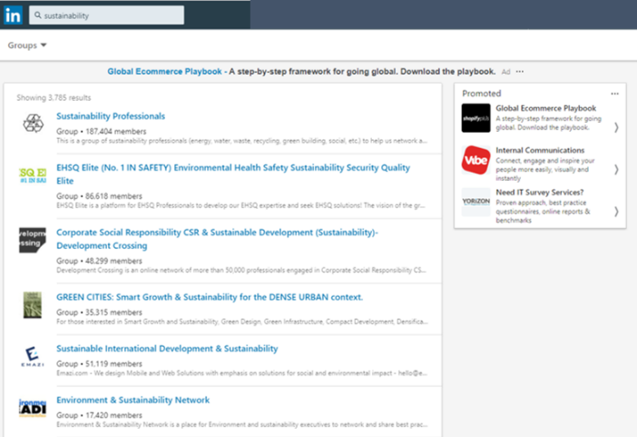

Image source: LinkedIn


The Johari Window Activity from Liberationist.org.

Your trainer will hand out a document entitled “Conquer Your
Blind Spots – Johari Window Model”. Instructions on what to
do are on the printout.

There is a plethora of resource material, including Case Studies for students to read that will support their knowledge
around Strategic Leadership. These documents are listed
under the Wider Reading Resources section.

Read the article: 15 Ways To Identify Bad Leaders by Mike Myatt
Read the academic article: Virtual Reality as an Emerging Methodology for Leadership Assessment and Training by
Ariano Alcañiz, Elena Parra, and Irene Alice Chicchi Giglioli
Prepare for assignment.

ART Day (when applicable)
09.00 – 10.00 Recap self-directed learning to date
10.00 – 10.15 Morning Tea
10.15 – 12.00 Assignment and readiness checks/resits
Any additional assigned tasks/work your
trainer has set you.

USEFUL ONLINE ARTICLS/READING MATERIAL
Business
Manaakitanga – unique New Zealand hospitality
The Interview: Marisa Bidois - the woman fronting New Zealand's $11b hospitality industry
Emerging Leaders Learn "A Fruit Bowl is not a Wellness Plan"
Technological change and the future of work (Focuses on New Zealand)
Leaders
9 of Hospitality’s Greatest Thought Leaders and Highest Achievers
Inspiring Women Leaders in Hotels (and How to Get More of Them in Boardroom)
Definitions
A Glossary of Hotel Acronyms, Abbreviations and Jargon
Glossary of hospitality industry terms – [INFOGRAPHIC]
The Ultimate Travel Tourism Glossary 2019
Change Leadership
The Critical Role of Leadership Development During Organisational Change
Implementing Leadership Theories Change Management
Organisational Change Theory
How Do Change Management Theories Help Organisations?
A Framework for Managing Change (references the hospitality sector)
Motivating employees
Motivating Employees After Business Changes
How to Motivate Your People Through Change
Nominal Group Technique (Decision Making)
Corporate Culture
Why Workplace Culture Matters in the Hospitality Industry
Destination Canada - Who We Are
Indonesia Tourism Development Corporation (ITDC)
white papers
Developing Great Leaders: A Measured Approach by Psychometrics
Infographics
5 Things to start and stop in Leadership
16 Things every leader should know
ADKAR Infographic
Bridges-Transition-Model-Infographic
Change Agents The role of Organisational Learning in Change Management
Eight Steps to Transforming Your Organisation Infographic
Guide to Organisational Culture Change
How Travel Makes You A Better Entrepreneur
Kotter's 8-Step Change Model Infographic
Leadership Habits
Leadership Leading for Growth
Leadership Scorecard
Lewin's Change Theory
Mastering the Role of Leader
McKinsey 7s Framework Template Infographic
McKinsey 7S-Model-Diagrams
Nudge Theory Now and Zen Infographic
Nudge-Theory-Infographic
People Management Tools Benefiting the Hospitality Industry
Smartsheet-IC-Comparison-of-Change-management-methodologies
Steering through Change
The Kubler-Ross Change Curve Infographic
The Kubler-Ross Model Infographic
The Leadership Deficit
The-Many-Uses-of-ADKAR Model -Infographic
XPLANE DNA of Change

USEFUL BOOKS (Check with Your Local Library)

Legacy
By James Kerr
https://bit.ly/32Y9NMn

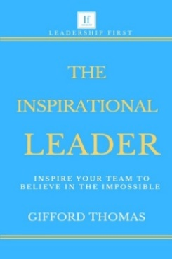
The Inspirational Leader
Inspire Your Team to Believe in The Impossible
By Gifford Thomas
https://bit.ly/2PBagA2

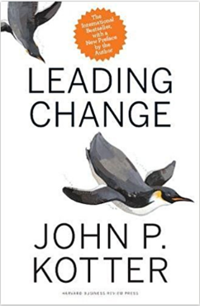
Leading Change
By John P. Kotter
https://bit.ly/31ZuCWe

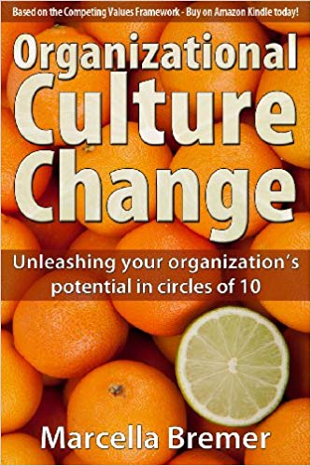
Organizational Culture Change: Unleashing your Organization's Potential in Circles of 10
By Marcella Bremer (Author), Marcel Lamers (Illustrator)
https://amzn.to/34aSbgo

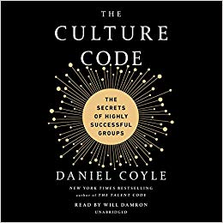
The Culture Code: The Secrets of Highly Successful Groups
By Daniel Coyle (Author), Will Damron (Reader)
https://amzn.to/2psGKlB

EXAMPLE: AUCKLAND LIBRARY
To find online resources using Auckland Council Libraries catalogue search, or a website search, just use this short URL: https://bit.ly/2kb354x
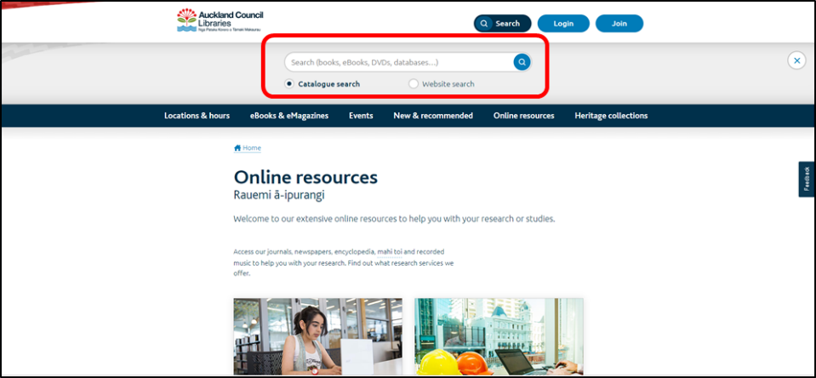
To join Auckland Library, just visit the website using the following short URL: https://bit.ly/2Vruukd


Out of zone subscriptions are available too:
Not based in Auckland?! You can choose any of these subscriptions:
- 12 months - $165.30
- 6 months - $82.60
- 3 months - $41.30
At any of our libraries, adults must provide personal identification to join the library. For example, Drivers Licence, Passport, Credit Card, 18+ card, Kiwi Access card or Community Services card.
Library Catalogue Search Webpages using short URLs:
Rotorua Library: https://bit.ly/2kE2MiQ
Wellington Library: https://bit.ly/1iLYZIg
Christchurch Library: https://bit.ly/2lNK6NE
Dunedin Library: https://bit.ly/2kFHkdb
Hamilton Library: https://bit.ly/2lJ7bRK


introduction
Welcome to the fifth course of Level 6.
Let’s kick-off Strategic Leadership with a stat. According to a 2019 New Zealand CEO survey by Price Waterhouse Cooper, PwC New Zealand, “84% of CEO’s think Artificial Intelligence (AI) will transform their businesses but 30% have no plans to pursue any AI initiatives at the moment”.
These days, strategic leaders are being challenged to think more strategically and be less operational in their focus. In other words, they need to become more than just leaders. They need to be strategic leaders. But how? And what exactly does this mean?
Strategic leaders are challenged to create focus in the business, to align tactics with strategy and to keep the long-term in mind despite short-term challenges. This is no small task given that the business environment requires increasing flexibility and resilience, while the internal “robustness” of the business demands increasingly complex, interdependent internal structures, systems and processes. It is the balancing of this tension that is the work of the strategic leader.
Strategic leaders understand that strategy is a learning process, rather than an event, and that effective strategic leadership involves a dynamic interplay between thinking strategically, acting strategically, building strategic relationships and influencing within those relationships with a view to the long-term, and constantly learning what we need to do to get there and how we might do it.
Source: Leadership Solutions ZA
Over the next three weeks, you will learn all about the following:
- What is a strategy?
- Leadership: Are leaders born or made?
- What is a theory? How to understand theories
- Transactional vs. Transformational leadership
- Effective leadership styles
- Change Management
- Creative Thinking using the Nominal Group Technique
- Business Profiles: Culture / Values / Communication
- How to respond to change
- The cost of change
- Measuring change
- Various case studies that apply the theory into effective practice


Let’s kick-off this module by asking you to reveal a little about your leadership style.
Finish off this sentence…
“A good leader should always …”
SKILL SESSION
How To BE EMPATHETIC
The term “empathy” is used to describe a wide range of experiences. Emotion researchers generally define empathy ‘as the ability to sense other people's emotions, coupled with the ability to imagine what someone else might be thinking or feeling.’

Source: Greater Good Magazine
Empathy: A Key to Effective Leadership
How many people do you interact with at NZST during a typical week or month?
Most leaders I know don’t count the relationships involved in their work. However, if they wrote a list of the people with whom they regularly interact, many would be able to go beyond a simple list and could tell you something about each person. Some information may be work-related (such as how each team member prefers to receive feedback), and other notes would be broader (such as which sports teams matter to the support staff and that a key vendor has a new grandchild).
Fundamentally, leadership involves relationships. Whether you’re the leader of a small team, the manager of a large retail store, or the CEO of a global corporation, you conduct work through your relationships with others. To be effective in those relationships, leaders must understand the perspectives of the people with whom they are working. What leaders need is Empathy, one of the twelve Emotional and Social Intelligence Leadership Competencies.
What is Empathy?
Empathy means having the ability to sense others’ feelings and how they see things. You take an active interest in their concerns. You pick up cues to what's being felt and thought. With empathy, you sense unspoken emotions. You listen attentively to understand the other person's point of view, the terms in which they think about what's going on.
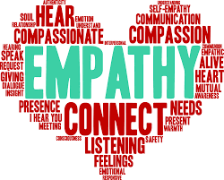
Neuroscientists have identified the different sections of the brain involved with two distinct types of empathy: cognitive empathy and emotional empathy. With cognitive empathy, we can understand the perspective of another person and the forces that informed that perspective. With emotional empathy, we pick up on the feelings of another person through verbal and nonverbal cues, and experience what they are feeling.
Empathy: An Important Leadership Skill
Does being skilled at empathy contribute to a leader’s performance?
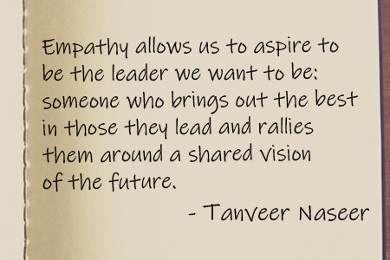
That’s a question, researchers at the Centre for Creative Leadership set out to answer when they looked at a sample of over 6,700 leaders from 38 countries. Here’s what they found: “Our results reveal that empathy is positively related to job performance. Managers who show more empathy toward direct reports are viewed as better performers in their job by their bosses. The findings were consistent across the sample: empathic emotion as rated from the leader’s subordinates positively predicts job performance ratings from the leader’s boss.”
How to Develop Empathy
As I mentioned, the experiences of cognitive and emotional empathy reside in specific parts of our brains. Given that neuroscientists have shown us that our brains can change, how can we enhance the parts of our brain related to empathy? The keys to making changes in our brain are repeated experiences and practice. Two of the “six habits of highly empathic people” from the Greater Good Science Centre at the University of California, Berkeley include curiosity and deep listening.
When we’re curious, we engage with others, even strangers, to learn more about their perspective. Standing in line at the grocery store, instead of reading messages on your phone, why not smile and ask the person next to you how they’re going to prepare the vegetables in their cart? Or when you’re early for a meeting, ask the other person waiting about something new they’ve learned this week in their job.
Then, once you’ve asked the question, stop and really pay attention to their answer. Listen both for the words being said and the feeling behind them. Does the person seem excited about a new recipe for broccoli they’re eager to try? Or harried and indifferent about what they’ll prepare for dinner? Does the person waiting for the meeting sound proud of their new learning? Or anxious about the implications of what they learned? Respond accordingly, with a sign that you understand, or offer a helpful comment.
One conversation won’t boost your empathy, but over time, exercising your curiosity and listening closely to others will help you sense more accurately how others think and feel.
Here are a few practical tips you might consider to help you:
- Listen – truly listen to people. Listen with your ears, eyes and heart. Pay attention to others' body language, to their tone of voice, to the hidden emotions behind what they are saying to you, and to the context.
- Don't interrupt people. Don't dismiss their concerns offhand. Don't rush to give advice. Don't change the subject. Allow people their moment.
- Tune in to non-verbal communication. This is the way that people often communicate what they think or feel, even when their verbal communication says something quite different.
- Practice the "93 percent rule". We know from a famous study by Professor Emeritus, Albert Mehrabian of UCLA, when communicating about feelings and attitudes, words – the things we say – account for only 7 percent of the total message that people receive. The other 93 percent of the message that we communicate when we speak is contained in our tone of voice and body language. It's important, then, to spend some time to understand how we come across when we communicate with others about our feelings and attitudes.
- Use people's name. Also, remember the names of people's spouse and children so that you can refer to them by name.
- Be fully present when you are with people. Don't check your email, look at your watch or take phone calls when a direct report drops into your office to talk to you. Put yourself in their shoes. How would you feel if your boss did that to you?
- Smile at people.
- Encourage people, particularly the quiet ones, when they speak up in meetings. A simple thing like an attentive nod can boost people's confidence.
- Give genuine recognition and praise. Pay attention to what people are doing and catch them doing the right things. When you give praise, spend a little effort to make your genuine words memorable: "You are an asset to this team because..."; "This was pure genius"; "I would have missed this if you hadn't picked it up."
- Take a personal interest in people. Show people that you care, and genuine curiosity about their lives. Ask them questions about their hobbies, their challenges, their families, their aspirations.
Sources: LinkedIn and MindTools


15 Questions to Make You a More Empathic Person
Interrogate assumed truths.
Challenging preconceived notions enables us to better navigate a world of diverse belief systems and conflicting opinions. Part of embracing empathy in your daily life means pushing to discover the big, messy, underlying reasons behind the beliefs and patterns you've always accepted without question.
Sometimes, we need to excavate the "why" behind seemingly fixed points, and demand contemplative responses from ourselves and others.
- When have your instincts led you astray?
- What are your personal biases that most interfere with finding truth?
- What types of questions make you most uncomfortable?
Creatively anticipate the needs of others.
There are times in your professional and personal life when it's up to you to intentionally cultivate space for other people to grow and thrive. This means learning what others need to be successful and figuring out how to give it to them without compromising your own sense of well-being.
- What about you most comforts others?
- What makes an experience meaningful?
- How do you balance being self-serving and selfless?
Constantly test and try.
To constantly improve yourself and your work, you need to be willing to test, fail, and pivot accordingly -- often over and over again. Remaining curious and patient in the face of failure is not without its emotionally charged challenges, but it creates resilience, focus, and a deep, first-hand appreciation for the victories and losses of those around you.
- When does your curiosity create difficulty?
- Who has challenged you to be better than you once were?
- How does iteration inform the outcome of your work?
Summon the patience to observe and absorb information.
Understanding is formed in those silent, observant moments of a deep conversation -- when we stop planning what to say next and focus instead on absorbing everything we can. You might be surprised how much you come to understand about the people around you when you give them a secure, non-judgmental space to confide.
- What role can silence play in a conversation?
- What should people better understand about you?
- When are you most observant?
Inhabit the here and now.
"Be present" isn't just a self-help mantra -- it's a reminder to acknowledge how you feel in a given moment and recognise the feelings of those around you. When you feel yourself becoming untethered from the present moment or clouded with concerns about the past or future, make a conscious effort to bring yourself back and check in.
- Where do you feel most present?
- When negative emotions arise, how do you deal with them?
- How do you stay grounded when the world gets overwhelming?
Source: HubSpot
- Active listening (AKA polite eavesdropping)
This exercise may have been intended for a college-level acting course, however, it’s also a great way to introduce you to empathy through active listening. Because individuals aren’t able to participate in the conversation, they’re focused on only listening to and observing the conversation, creating a unique space for openly and actively listening
How to do it
When: Typically, one week is sufficient time to allow you to actively listen to at least one conversation.
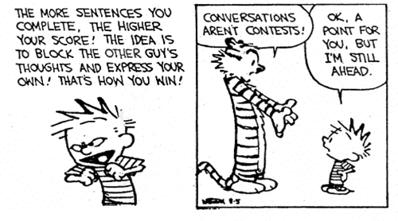
How: Before you head out to politely eavesdrop on unsuspecting people, it’s important to first express the intent of this exercise and remind you that the goal is not to invade anyone’s privacy, but rather to actively pick up on bits of conversations we’d hear in our normal daily lives. You shouldn’t seek out conversations to listen in on, necessarily, but rather pay closer attention to the conversations around you, and actively listen to what you hear in the time you’d normally be within earshot. Active listening is in part about listening to understand and clarify what the individual is saying. It’s not about competing, talking down or responding with our own opinion before acknowledging the speaker’s.
- Good Things
Turn to one of your classmates and tell him or her something good; specifically, finish one of these positive talking sentences (Alber, 2017):
- One good thing in my life is…
- Something good that happened is…


Sharing the ‘good thing’ will put you in a more positive frame of mind, and by sharing something personal and good with others will make you feel heard and acknowledged by others.

Leaders You Love
There are many great leaders in every field and era. Often our sights are set on specific leadership skills that resonate with us, but that myopic view can leave other important attributes in the shadows.
In small groups of three, discuss leaders that you know or admire and state why you have chosen them.
what is strategy? and what does it mean to be strategic?
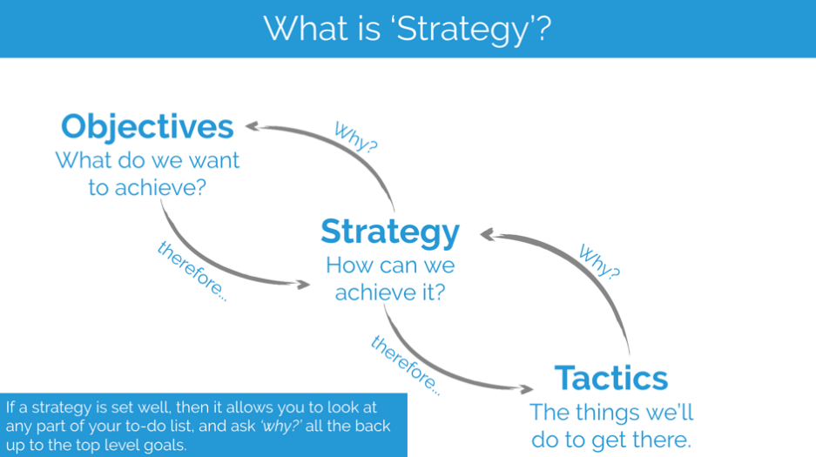
Source: Moz
As part of this module, you will learn how to put the ‘strategic’ into leadership. But what is a strategy and how can leaders demonstrate to become strategic?

The term ‘strategic’ is overused and often misused, says Tim Williams. Marketing professionals should think more carefully about using the word, as calling people ‘strategic’ can make everyone else with a non-strategy role feel unnecessarily undervalued.
Right alongside ‘full service’ and ‘integrated’, the term ‘strategic’ is one of the most misused (and overused) terms in the lexicon of agencies and brands alike. It’s an expression that has lost its meaning.
The word ‘strategy’ is a fairly recent addition to the business vocabulary. Until the 1950s, strategy was almost exclusively a military concept, used as far back as the Romans (who, of course, used the proper Latin term ‘stratagem’). Peter Drucker, a brilliant business mind who used the word sparingly, helped popularise the concept by referring to it as ‘strategic management’. In reality, there was a wholesale import of military terminology into the marketing sphere. We support strategies with ‘tactics’ and ‘target’ consumers with ‘campaigns’. In effect, marketing decided to borrow the language of war.
No doubt many of us confuse ‘tactics’ with ‘strategies’ – a common mistake even for seasoned professionals. But an even more pernicious habit is our tendency to use the word ‘strategic’ when what we really intend to connote is ‘smart’.
What do we really mean when uttering the following phrases? ‘Let’s assign this to Julie; she’s very strategic.’ Translation: Julie is bright. ‘Let’s think strategically about this problem.’ Translation: Let’s apply some critical thinking to this. ‘This campaign is creative, but it’s not very strategic.’ Translation: This work is unlikely to accomplish the client’s objectives. ‘Francisco is one of the most strategic people on the team.’ Translation: Francisco is our most knowledgeable colleague.
The other equally consequential result of the misuse of the word is that it unfairly and inaccurately divides the marketing world into two classes of people: those who are strategic and those who aren’t. Project managers aren’t expected to be strategic in the sense that they can develop a brilliant creative brief, but they are strategic in the way they plan and manage resources.
The word strategy is synonymous with approach, plan of action, roadmap, blueprint, or game plan. Many professionals, not just those with the title strategist, are capable of developing productive approaches to solving problems in their areas of responsibility. A good brand planner is capable of crafting an effective brand architecture, but a talented production manager is equally capable of building an efficient production architecture.
In a business context, strategic thinking involves the generation and application of unique insights and opportunities intended to create competitive advantage for a firm or organisation (so says Wikipedia). Seen this way, your organisation is likely filled with ‘strategic thinkers’ who don’t have anything close to a strategy title.
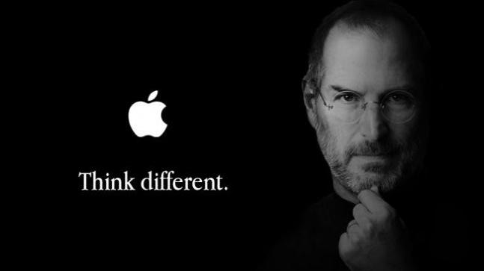
Image source: IndiaToday

A strategist is also one who plans and directs. According to dictionary definitions, just being a co-ordinator qualifies one as a strategist, because this involves having the skills to effectively execute against a plan. We might even think of the very best strategists as orchestrators.
In one of the most memorable scenes from the recent movie Steve Jobs, Jobs and his friend and Apple co-founder Steve Wozniak are engaged in a passionate discussion in an orchestra pit prior to Jobs going on stage for a new product introduction. Wandering amid the music stands, Woz is maddened by the fact that Jobs gets all the credit for Apple despite not even knowing how to put together a circuit board (which, of course, Woz does). “What exactly do you do?” Woz demands. Thinking for a moment, Jobs replies, “I play the orchestra.”
In this highly successful partnership, one could conclude that Jobs was the strategist. But not in the sense that Jobs was the smart one. Jobs possessed a different type of intelligence than Wozniak, but Woz was (and still is) brilliant in his area of expertise. Let’s not confuse the idea of being strategic with being brainy.
Marketing organisations are not comprised of ‘thinkers’ and ‘doers’. Everyone thinks and everyone does; we just think and do different things in different ways. If we mean to imply someone is bright, sharp, perceptive, well-informed, educated, or clever, let’s use that very language. To instead say they are strategic makes everyone else with a non-strategy role feel unnecessarily undervalued.
Words matter, and we marketing professionals should understand that most of all. We can better respect the talents of everyone on the teams we work with through more precise and careful use of the word strategic.
Source: Warc

Good strategies are compounds, not elements.


Image source: Moz
A good starting point for understanding strategy is an infamous article by Michael E. Porter – "What is Strategy?" It’s quite academic, but covers a lot of the key points. I recommend reading it a few times; it’s worth it.

To understand what strategy is, I like to use a chemical analogy of elements and compounds. A compound is a combination of two or more elements. In the case of a strategy, the activities would be the elements and the strategy would be the compound. I like this analogy for a few reasons:

Reverse-engineering a compound can be challenging
Many people fall into the trap of trying to copy a competitor's strategy. This is bad for a number of reasons, but one in particular that I’d like to highlight: even if you think you know what a competitor's strategy is from the outside, it can be very hard to copy successfully unless you know all of the individual details.

Much like a chemical reaction, different quantities of the same elements combined in different ways can produce very different results. Often, when people try to copy a strategy, they’re really just copying an element or activity.

Compounds are only as strong as their weakest link

Different strategies take different levels of energy to crack. In What is Strategy?, this idea is referred to as “activity systems” and “fit.” The example used is Southwest Airlines. Some people would try and describe a strategy as a slogan: “Southwest Airlines services price- and convenience-sensitive customers.” That might be true, but there’s not anything particularly advantageous about that idea. The competitive advantage comes from how they integrate:

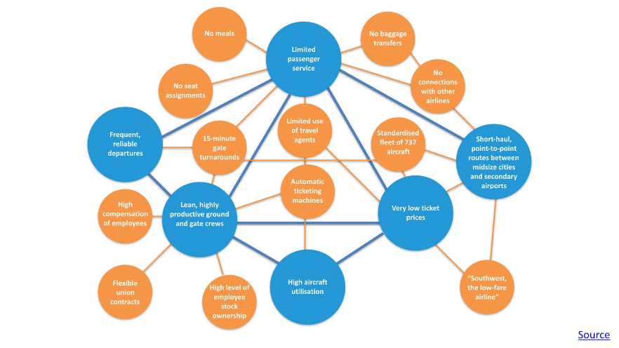
“Through fast turnarounds at the gate of only 15 minutes, Southwest is able to keep planes flying longer hours than rivals and provide frequent departures with fewer aircraft. Southwest does not offer meals, assigned seats, interline baggage checking, or premium classes of service. Automated ticketing at the gate encourages customers to bypass travel agents, allowing Southwest to avoid their commissions. A standardised fleet of 737 aircraft boosts the efficiency of maintenance.”

This is what those individual pieces look like as part of a system: The more stable the compound, the slower it reacts.

A stable compound with lots of bonds, while strong and hard to copy, is slow to adapt if the market changes unexpectedly. Change forces managers to dismantle their existing resource systems and reassemble them in new strategic positions.

All of the above is to say that the key to an effective and sustainable strategy is to focus on the integration of activities. Operational efficiency alone isn’t a strategy. A good way to sanity-check this is by asking why you're doing an activity.

One of the hardest things about strategy? Resisting the urge to do it all. The most obvious way this happens is by getting distracted by competitors. In the book The Secrets of Consulting, the first chapter introduces the idea of the law of strawberry jam: "the wider you spread it, the thinner it gets,” which is a nice way of saying that you can’t do it all. Every service or feature you add to your business has a cost of some kind. Trade-offs are a critical part of making sure your strategy is sustainable, because they protect from competitors trying to straddle multiple markets.

To go back to the previous example of Southwest Airlines, someone that tried to spread it far and thick was Continental Lite. By trying to copy Southwest and offer a low-cost airline solution while still trying to compete as a full-service airline:

“The airline dubbed the new service Continental Lite. It eliminated meals and first-class service, increased departure frequency, lowered fares, and shortened turnaround time at the gate. Because Continental remained a full-service airline on other routes, it continued to use travel agents and its mixed fleet of planes and to provide baggage checking and seat assignments.” Source: What is Strategy?
If you haven’t made some trade-offs, your position probably isn’t sustainable and is open to imitation.
“Trade-offs ultimately grounded Continental Lite. The airline lost hundreds of millions of dollars, and the CEO lost his job. Its planes were delayed leaving congested hub cities or slowed at the gate by baggage transfers. Late flights and cancellations generated a thousand complaints a day. Continental Lite could not afford to compete on price and still pay standard travel-agent commissions, but neither could it do without agents for its full-service business. The airline compromised by cutting commissions for all Continental flights across the board. Similarly, it could not afford to offer the same frequent-flier benefits to travellers paying the much lower ticket prices for Lite service. It compromised again by lowering the rewards of Continental’s entire frequent-flier program. The results: angry travel agents and full-service customers.”
The short version is that when competitors copy each other, the only person that wins is the customer. Over the long term, the more competitors converge, the more they look like each other and customers default to price to help choose between options. This drives prices down and squeezes margins.

Adapted article. Source: Moz

According to the Centre for Simpliied Strategic Planning, Strategic Thinking requires 11 Critical Skills. What are these ‘critical’ skills?

strategic leadership – qualities of a strategic leader
Strategic leadership refers to a manager’s potential to express a strategic vision for the organisation, or a part of the organisation, and to motivate and persuade others to acquire that vision. Strategic leadership can also be defined as utilising strategy in the management of employees. It is the potential to influence organisational members and to execute organisational change. Strategic leaders create organisational structure, allocate resources and express strategic vision. Strategic leaders work in an ambiguous environment on very difficult issues that influence and are influenced by occasions and organisations external to their own.

The main objective of strategic leadership is strategic productivity. Another aim of strategic leadership is to develop an environment in which employees forecast the organisation’s needs in context of their own job. Strategic leaders encourage the employees in an organisation to follow their own ideas. Strategic leaders make greater use of reward and incentive system for encouraging productive and quality employees to show much better performance for their organisation. Functional strategic leadership is about inventiveness, perception, and planning to assist an individual in realising his objectives and goals.

Strategic leadership requires the potential to foresee and comprehend the work environment. It requires objectivity and potential to look at the broader picture.


In small groups, rank by importance the following traits / characteristcs / features and qualities.

Loyalty
Powerful and effective leaders demonstrate their loyalty to their vision by their words and actions.

Keeping them updated
Efficient and effective leaders keep themselves updated about what is happening within their organisation. They have various formal and informal sources of information in the organisation.

Judicious use of power
Strategic leaders makes a very wise use of their power. They must play the power game skillfully and try to develop consent for their ideas rather than forcing their ideas upon others. They must push their ideas gradually.

Have wider perspective/outlook
Strategic leaders just don’t have skills in their narrow specialty but they have a little knowledge about a lot of things.

Motivation
Strategic leaders must have a zeal for work that goes beyond money and power and also they should have an inclination to achieve goals with energy and determination.

Compassion
Strategic leaders must understand the views and feelings of their subordinates, and make decisions after considering them.

Self-control
Strategic leaders must have the potential to control distracting/disturbing moods and desires, i.e., they must think before acting.

Social skills
Strategic leaders must be friendly and social.

Self-awareness
Strategic leaders must have the potential to understand their own moods and emotions, as well as their impact on others.

Readiness to delegate and authorise
Effective leaders are proficient at delegation. They are well aware of the fact that delegation will avoid overloading of responsibilities on the leaders. They also recognise the fact that authorising the subordinates to make decisions will motivate them a lot.

Articulacy
Strong leaders are articulate enough to communicate the vision (vision of where the organisation should head) to the organisational members in terms that boost those members.

Constancy/ Reliability
Strategic leaders constantly convey their vision until it becomes a component of organisational culture.

Source: The Management Study Guide

the 10 principles of strategic leadership
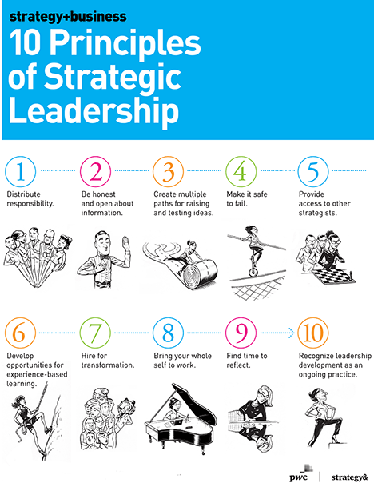
Most companies have leaders with the strong operational skills needed to maintain the status quo. But they face a critical deficit: They lack people in positions of power with the know-how, experience, and confidence required to tackle what management scientists call “wicked problems.” Such problems can’t be solved by a single command, they have causes that seem incomprehensible and solutions that seem uncertain, and they often require companies to transform the way they do business. Every enterprise faces these kinds of challenges today.

A 2015 PwC study of 6,000 senior executives, conducted using a research methodology developed by David Rooke of Harthill Consulting and William Torbert of Boston University, revealed just how pervasive this shortfall is. Respondents were asked a series of open-ended questions; their answers revealed their leadership preferences, which were then analysed to determine which types of leaders were most prominent. Only 8 percent of the respondents turned out to be strategic leaders, or those effective at leading transformations (Rooke and Torbert refer to them as “strategist” leaders).

Strategy + Business: Find Your Strategic Leaders – 2.13 mins
Https://Youtu.Be/Dpesxyfk6ha

The study suggests that strategic leaders are more likely to be women (10 percent of the female respondents were categorised this way, versus 7 percent of the men), and the number of strategic leaders increases with age (the highest proportion of strategic leaders was among respondents age 45 and above). These leaders tend to have several common personality traits: They can challenge the prevailing view without provoking outrage or cynicism; they can act on the big and small pictures at the same time, and change course if their chosen path turns out to be incorrect; and they lead with inquiry as well as advocacy, and with engagement as well as command, operating all the while from a deeply held humility and respect for others.

It may seem disheartening that such a small percentage of senior leaders can operate this way. The trend over time is almost as bad. When the same survey was conducted in 2005, only 7 percent of respondents were identified as strategic leaders. In other words, in the course of a transformative decade marked by the collision of technological breakthroughs, financial crises, demographic shifts, and other major global forces, the leadership needle barely moved.

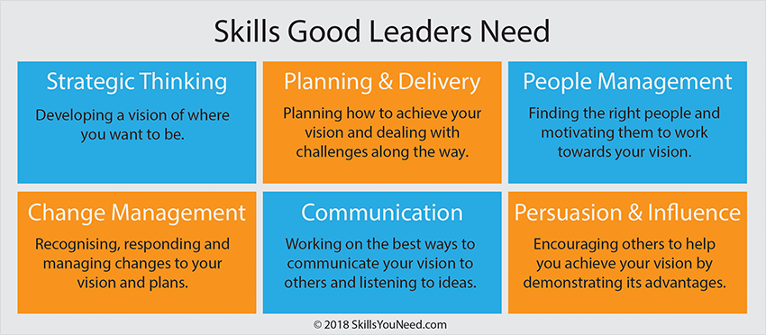
Image source: SkillsYouNeed


are leaders born or made?
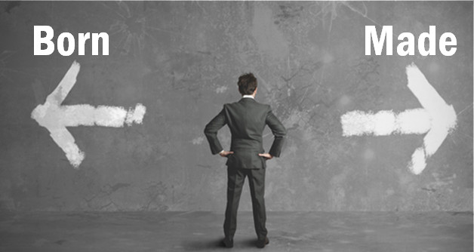

An online article on LinkedIn written by Brigette Hyacinth has asked the following question: Which came first the chicken or the egg? To be or not to be? Nature versus Nurture?

Can we finally put this age old argument to rest and come to a conclusion.

Leadership: “Exercising of influence over others on behalf of the leader's purposes, aims or goals. “

Leaders are born not made:
Great Man theory and Trait theories believe that people inherit certain qualities and traits that make them better suited to leadership.

To suggest that leaders do not enter the world with extraordinary endowment is to imply that people enter the world with equal abilities, with equal talents.” (Thomas Carlyle 1840)

There are certain inborn characteristics that predispose people to be and become leaders. There is a significant difference between “learning a skill” and mastering one, in the same way that others are born with amazing musical gifts or athletic talents. They will excel naturally in these areas but others would be like a fish out of water and may struggle to get to the same point.

Born (natural) Leaders are different to made (artificial leaders). All remarkable leaders have great history behind them. They were leaders from the onset of their journey.

If leaders were solely born what is the point of the rest of us studying leadership or management?

Birth is a natural process and the notion to associate leadership with it is arguable.

Leaders are made not born:
Behavioural Theories believe that people can become leaders through the process of teaching, learning and observation. Leadership is a set of skills that can be learned by training, perception, practice and experience over time. Leadership learning is lifetime activity. Good leaders seek out development opportunities that will help them learn new skills.

The military embraces this doctrine which is evident through its leadership training programme.

Can enrolling for a programme on management and leadership makes someone a leader upon completion? Can Charisma, Influence,Integrity and the ability to Inspire be taught? Will the granting of a certificate and a few letters after one’s name make them a leader?

Soft skills can be explained, but not implanted. The ability to share your vision takes more than a sophisticated PowerPoint presentation and some crisp words on a bunch of 4x6 cards.

Leadership can be learned by anyone with the basics. But an awful lot of leadership cannot be taught. Some do well but others find themselves poorly equipped rendering mediocre results.

The Verdict:
Leadership is an art rather than a science. It is a set of innate traits, refined and perfected over time with education, training and experience.

There is also an aspect of being in the right place in the right time. You may be a leader but also a matter of whether or not you are in the position within which your talents can shine forth.

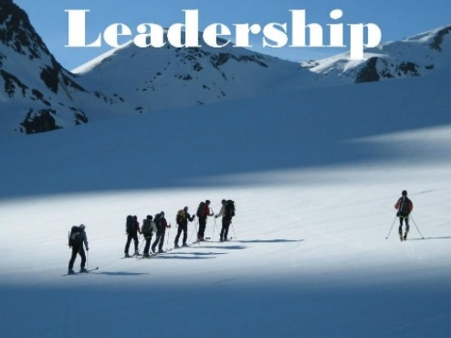
The discussion about leadership also needs to identify the location as well as the environment. Are we speaking about these major performers (born or made) in a small organisation, in an industry, in a society, in a country or in the world?

If the fear of leading overrides the willingness to take on the responsibilities then one is a follower. Not everyone can be a leader just like not everyone can become a good actor. Some people will never have that aspect in them while others have the latent ability and thus can be taught how to lead. All the books, classes education and training cannot turn a follower into a leader.

To be a leader in a structured environment, one needs some formal training. Most people can learn to manage well, start a business, lead a project team since good management is based on rules - rules that can be learned and mastered.

Leadership is often a Choice. A leader is a person who comes forward to take the challenge. If a leader rises up from the multitude, then that person was already a leader to begin with. Should someone have all the best training, nurturing and opportunities, but would rather be hidden in the crowd, an unwilling participant...not a leader.

Leadership styles varies with maturity, followers and situations.

In the GLOBE research across 60 countries leader attributes conclusions were thus: “Integrity; charisma, inspirational, visionary, encouraging, positive, confidence builder, dynamic, foresight, effective team building, communicating, coordinating, decisive, intelligent, and win-win problem solver,” These attributes are a combination of personality, character, skill, communicative ability, and emotional intelligence. Therefore a leader is born, developed, skilled in communications, and cultivated through life experiences.

The best estimates offered by research is that leadership is about one-third born and two-thirds made.

It all depends on how one defines leadership. It is possible for either. Depending on how you define leadership everyone can lead and be a leader.

Perhaps we should seek to quantify leaders rather than qualify.
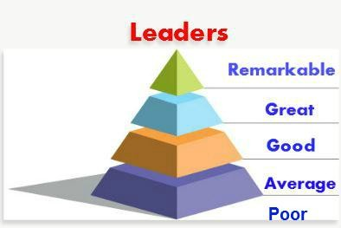
Remarkable Leaders would include the likes of Nelson Mandela, Mahatma Ghandi, Martin Luther King Jr, Aung San Suu Kyi…etc. Individuals that seek neither wealth nor fame, selfless, loved justice, passionate about people and worked for the greater good of others.

In studying leadership, the theories can be overwhelming. It is evident you cannot really support a side and negate the other. Although there are thousands of books, decade’s worth of well documented studies, the debate can go on forever without converging to a logical conclusion.

That’s why I would like to share a true story. Well, my story.

My Story:
From the time I was little, all the elderly villagers (who have long past) would tell my mother “This child is different”. I was always focused and driven and had a passion and desire to lead. I was not born with a golden spoon or a silver spoon or any other spoon for that matter. Things were extremely tough growing up. I am actually the only one in all my relatives to have attained undergraduate education. My mother is now taking literacy classes, and I am so proud of her.

I remember two moments quite vividly from my early childhood. The first was having a conversation with my mother when I was around 5 years and telling her I wanted to go to school. But at that time she could not afford to send me. The second was playing marbles around 7 or 8 years with a neighbour and hearing his mother whispering to him, “Why are you playing with Brigette. She is so serious.” I was just persistent and well competitive.

Whilst most of the people in my community accepted being a victim of circumstances and floated downstream, I instinctively paddled upstream against the prevailing currents. Was it hard? “Yes”. Was it lonely? “Yes”. Did I get depressed? “Yes”. Yet, I was compelled to keep moving forward. Thank God!
I believe there must be some deep rooted spark if not an intense fire within. Are leaders born OR made? I beg to differ and shift the gauge to read both. Leaders are both born and made.

The Pareto principle named after economist Vilfredo Pareto, also known as the 80—20 rule states that for many events, roughly 80% of the effects come from 20% of the causes. It observes that most things have an unequal distribution. According to this principle, leaders are 80 percent made and 20 percent born. However, studies conducted out of the University of Illinois, support past research that leadership is 30 percent genetic and 70 percent learned. As to how the percentage is precisely divided between both born and made, I believe this may be subject to individual circumstances, since no two leaders will have the exact ratios listed above.

Source: LinkedIn

The big debate. From your understanding of this article, are leaders born or made?

SKILL SESSION
what is a theory / understanding theory?
This section of the module seeks to discuss some of the many theorists on leadership such as Belbin, Maslow, Adair and Tuckman.

However, and before you start to learn all about some of the respected leadership theorists, what is a theory and how should theories be understood?

Reviewing theories allows the reader to learn about the language (and/or correct terminology), structure questions around the subject matter and opens the door for challenges, to name but a few.

Have you heard about theory of Flat-Earth? If not, then have we go news for you!



Flat-Earthers are back: 'It’s almost like the beginning of a new religion'

Looks pretty flat from this angle ... Photograph: YouTube

Editor's Note: An original version of this article, written by Natalie Wolchover, appeared on Live Science Oct. 26, 2012. An updated version by Live Science staff was republished on May 30, 2017.

Members of the Flat Earth Society claim to believe the Earth is flat. Walking around on the planet's surface, it looks and feels flat, so they deem all evidence to the contrary, such as satellite photos of Earth as a sphere, to be fabrications of a "round Earth conspiracy" orchestrated by NASA and other government agencies.

The belief that the Earth is flat has been described as the ultimate conspiracy theory. According to the Flat Earth Society's leadership, its ranks have grown by 200 people (mostly Americans and Britons) per year since 2009. Judging by the exhaustive effort flat-earthers have invested in fleshing out the theory on their website, as well as the staunch defenses of their views they offer in media interviews and on Twitter, it would seem that these people genuinely believe the Earth is flat.

But in the 21st century, can they be serious? And if so, how is this psychologically possible?
How do we know the Earth is round? – 2.13 mins
Https://Bit.Ly/2w2gnfn
Through a flat-earther's eyes
First, a brief tour of the worldview of a flat-earther: While writing off buckets of concrete evidence that Earth is spherical, they readily accept a laundry list of propositions that some would call ludicrous. The leading flat-earther theory holds that Earth is a disc with the Arctic Circle in the center and Antarctica, a 150-foot-tall wall of ice, around the rim. NASA employees, they say, guard this ice wall to prevent people from climbing over and falling off the disc. (In keeping with their skepticism of NASA, known flat-earther conspiracy theorist Nathan Thompson recently approached a man he said was a NASA employee in a Starbucks in mid-May 2017. In a YouTube video of the exchange, Thompson, founder of the Official Flat Earth and Globe Discussion page, shouted that he had proof the Earth is flat — apparently saying an astronaut drowning was that proof — and that NASA is "lying.")

Earth's day and night cycle is explained by positing that the sun and moon are spheres measuring 32 miles (51 kilometers) that move in circles 3,000 miles (4,828 km) above the plane of the Earth. (Stars, they say, move in a plane 3,100 miles up.) Like spotlights, these celestial spheres illuminate different portions of the planet in a 24-hour cycle. Flat-earthers believe there must also be an invisible "antimoon" that obscures the moon during lunar eclipses.

Furthermore, Earth's gravity is an illusion, they say. Objects do not accelerate downward; instead, the disc of Earth accelerates upward at 32 feet per second squared (9.8 meters per second squared), driven up by a mysterious force called dark energy. Currently, there is disagreement among flat-earthers about whether or not Einstein's theory of relativity permits Earth to accelerate upward indefinitely without the planet eventually surpassing the speed of light. (Einstein's laws apparently still hold in this alternate version of reality.)

As for what lies underneath the disc of Earth, this is unknown, but most flat-earthers believe it is composed of "rocks." [Religion and Science: 6 Visions of Earth's Core]

Then, there's the conspiracy theory: Flat-earthers believe photos of the globe are photoshopped; GPS devices are rigged to make airplane pilots think they are flying in straight lines around a sphere when they are actually flying in circles above a disc. The motive for world governments' concealment of the true shape of the Earth has not been ascertained, but flat-earthers believe it is probably financial. "In a nutshell, it would logically cost much less to fake a space program than to actually have one, so those in on the Conspiracy profit from the funding NASA and other space agencies receive from the government," the flat-earther website's FAQ page explains.

Who believes the Earth is flat?
Flat-earth believers are not relegated to the hidden corners of the universe: Plenty of celebs have been quite vocal with their beliefs. For instance, on Jan. 25, 2016, rapper-singer Bobby Ray Simmons Jr. (known as B.o.B) released a track called "Flatline" in which he disses astrophysicist Neil deGrasse Tyson, after the two had a Twitter battle over the spherical-ness of the planet. B.o.B is convinced Earth is flat. A day earlier, the rapper tweeted: "No matter how high in elevation you are... the horizon is always eye level ... sorry cadets... I didn't wanna believe it either."

And then there's Shaq. In a podcast that aired on Feb. 27, 2017, former NBA player Shaquille O'Neal proclaimed our home planet is flat, saying that when he drives from Florida to California "it's flat to me." Shaq later said he was just kidding.

Some believers have gotten creative in their quest to prove a flat planet: Conspiracy theorist D. Marble posted on YouTube on May 1, 2017, that he brought a spirit level aboard a flight from Charlotte, North Carolina to Seattle, Washington, to see whether the plane's nose would dip to "compensate for curvature" of the Earth, he said. On the video, he said: "I recorded a 23 minute and 45 second time-lapse, which by those measurements means the plane travelled a little over 203 miles. According to Spherical Trigonometry given to explain the Heliocentric model, this should have resulted in the compensation of 5 miles of curvature. As you'll see there was no measurable compensation for curvature." (The air bubble in his level remained centered, which he said proves the Earth is flat.)

The Zetetic Method
The theory follows from a mode of thought called the "Zetetic Method," an alternative to the scientific method, developed by a 19th-century flat-earther, in which sensory observations reign supreme. "Broadly, the method places a lot of emphasis on reconciling empiricism and rationalism, and making logical deductions based on empirical data," Flat Earth Society vice president Michael Wilmore, an Irishman, told Life's Little Mysteries. In Zetetic astronomy, the perception that Earth is flat leads to the deduction that it must actually be flat; the antimoon, NASA conspiracy and all the rest of it are just rationalisations for how that might work in practice.

Those details make the flat-earthers' theory so elaborately absurd it sounds like a joke, but many of its supporters genuinely consider it a more plausible model of astronomy than the one found in textbooks. In short, they aren't kidding. [50 Amazing Facts About Planet Earth]

"The question of belief and sincerity is one that comes up a lot," Wilmore said. "If I had to guess, I would probably say that at least some of our members see the Flat Earth Society and Flat Earth Theory as a kind of epistemological exercise, whether as a critique of the scientific method or as a kind of 'solipsism for beginners.' There are also probably some who thought the certificate would be kind of funny to have on their wall. That being said, I know many members personally, and I am fully convinced of their belief."

Wilmore counts himself among the true believers. "My own convictions are a result of philosophical introspection and a considerable body of data that I have personally observed, and which I am still compiling,” he said.

Strangely, Wilmore and the society's president, a 35-year-old Virginia-born Londoner named Daniel Shenton, both think the evidence for global warming is strong, despite much of this evidence coming from satellite data gathered by NASA, the kingpin of the "round Earth conspiracy." They also accept evolution and most other mainstream tenets of science.

Conspiracy theory psychology
As inconceivable as their belief system seems, it doesn't really surprise experts. Karen Douglas, a psychologist at the University of Kent in the United Kingdom who studies the psychology of conspiracy theories, says flat-earthers' beliefs cohere with those of other conspiracy theorists she has studied.

"It seems to me that these people do generally believe that the Earth is flat. I'm not seeing anything that sounds as if they're just putting that idea out there for any other reason," Douglas told Live Science.

She said all conspiracy theories share a basic thrust: They present an alternative theory about an important issue or event, and construct an (often) vague explanation for why someone is covering up that "true" version of events. "One of the major points of appeal is that they explain a big event but often without going into details," she said. "A lot of the power lies in the fact that they are vague."

The self-assured way in which conspiracy theorists stick to their story imbues that story with special appeal. After all, flat-earthers are more adamant that the Earth is flat than most people are that the Earth is round (probably because the rest of us feel we have nothing to prove). "If you're faced with a minority viewpoint that is put forth in an intelligent, seemingly well-informed way, and when the proponents don't deviate from these strong opinions they have, they can be very influential. We call that minority influence," Douglas said.

In a study published online March 5, 2014, in the American Journal of Political Science, Eric Oliver and Tom Wood, political scientists at the University of Chicago, found that about half of Americans endorse at least one conspiracy theory, from the notion that 9/11 was an inside job to the JFK conspiracy. "Many people are willing to believe many ideas that are directly in contradiction to a dominant cultural narrative," Oliver told Live Science. He says conspiratorial belief stems from a human tendency to perceive unseen forces at work, known as magical thinking.

However, flat-earthers don't fit entirely snugly in this general picture. Most conspiracy theorists adopt many fringe theories, even ones that contradict each other. Meanwhile, flat-earthers' only hang-up is the shape of the Earth. "If they were like other conspiracy theorists, they should be exhibiting a tendency toward a lot of magical thinking, such as believing in UFOs, ESP, ghosts, or other unseen, intentional forces," Oliver wrote in an email. "It doesn't sound like they do, which makes them very anomalous relative to most Americans who believe in conspiracy theories."
The idea of using this example is to teach you that not all theories are ‘set in stone’, so to speak. You can challenge them. And, you can question the context. In fact, many choose to.

So, what is a theory? And how are theories developed?

A theory is a method we use to give us understanding.

One of the major purposes of a theory is to provide an answer to the question ‘why?’. Asking, ‘why?’, to increase your knowledge of a subject area and realign your thoughts and opinions is an essential skill for anybody who wants to learn and develop.

‘Why’ is one of the very first questions that children ask:

“Can you get ready for bed now?” … “Oh why?”
“Why is snow cold?”
“Why do I have to go to school tomorrow?”
“Why is the sky blue?”

Questions like these, from children, can be endless. Often finding or providing suitable explanations can be exhausting and frustrating – perhaps we resort to saying, “Well it just is!” At the basis of such questions however, are a child’s first attempts to understand the world around them, and develop their own theories of why things are the way they are.

Defining ‘theory’, therefore, has to take into account the ‘why?’ question, but a theory is deeper than that. The points below go some way to helping with a definition.

- A theory is an attempt to explain why and so to provide understanding.

- A theory is not just ‘any’ explanation - a theory comes into being when a series of ideas come to be held and accepted by a wider community of people.

- A theory is not necessarily factually based – how we understand and provide explanations arises from our cultural background and how we view the world.

Understanding Theory

Although there are no hard and fast rules, modern theory is usually developed through a series of steps, by academics and scientists.

It is important to understand that the steps to theory development, as listed on this page, are generally thought of as being sequential – one step follows the last.

In reality there is often more than one of these processes being engaged in at any one time.

From Observation to Understanding

- Observation (usually the effect)
- Description
- Possible theory - hypothesis
- Reading - placing individual understanding in context
- Research
- More reading
- Accepting, rejecting or modifying a hypothesis
- Theory – understanding why – and this being accepted by a wider community of people

Hypothesis – The Research Question
Following on from observation and description, a tentative understanding as to ‘why’ may be formulated and this is known as a hypothesis or the research question. This is usually to explore the cause, e.g. ‘why’ the apple fell to the ground?

Reading and Placing in Context
Reading from a wide range of sources is important; reading may take place at any stage within this sequence of events. Reading allows the researcher to place their information in context. It is usual for the researcher to have undertaken a considerable amount of reading prior to undertaking their research.

It is also possible that reading around the subject leads to a new research question. Whilst reading around a subject to gain an understanding, a researcher may discover a ‘gap’ in the current knowledge that they wish to fill.

Research
Research is then undertaken to ‘test’ the hypothesis or to explore the research question. For the natural scientist, this usually involves controlled scientific experimentation, which is repeatable time and time again and should provide the same (or similar) results.

For the social scientist or social researcher, such experimentation is more difficult, sometimes impossible to orchestrate. There are, however, many research tools that a social researcher can deploy to investigate their research question.

Accepting, Rejecting, or Modifying a Hypothesis:
The Research Question
Once research has been undertaken within scientific research this can lead to accepting, rejecting, or modifying the hypothesis. For the social researcher there may not be any firm conclusions drawn to allow this process to take place; it is usual that research leads to more research and further questions being explored. Definitive answers may be difficult to ascertain - there may be a host of reasons given and these reasons may change over time. Research findings from both the scientific and the social research community do, however, need to be discussed more widely prior to their becoming accepted.

This process is usually undertaken with a ‘discussion’ of findings with the wider community, e.g. other researchers and academics with an interest in the area. Within academia this can involve presenting findings and papers at conferences and seminars. This means that the findings from the research undertaken do not exist in isolation. Other academics may wish to carry out similar experiments etc.

Publication
The wider academic community exists, in part, to contribute to and/or scrutinise the content of academic materials, research journals, articles or chapters in books. What is important is that these areas are ‘peer reviewed’ prior to publication and the research presented is rigorously debated. The researcher may be asked to review their work prior to publication or indeed it may be rejected. Once published, such ideas can become part of the ‘system of ideas’.

Theories around particular subjects tend to fall in and out of ‘fashion’. As society changes, additional information is discovered or attitudes change then so too do theories and the explanation as to ‘why’. Whilst this is the case, it is important to remember that even though theories may come to be discredited over time - as thinking about a subject changes - they can prove highly influential. A good example here, might be the work of Sigmund Freud.

Social Understanding
Gaining an understanding around the behaviour of people and society is much more problematic (people are inconsistent and society is constantly changing) than within the natural sciences, where natural phenomena are generally more consistent.

It is also important to note that within this realm, it is easier to appreciate that understandings and theories created are specific to the people or persons who are creating the theory, the time and place in which they were writing, i.e. their whole social, cultural and economic context.

Their observations (as are our own) are biased, that is, seen through their eyes and understood from their own background, assumptions etc. Theories and ideas, therefore, can be built upon and expanded and can be discredited. Even so, certain theoretical perspectives have had enormous influence around our thinking, understanding and practice within our society, such as the work of Sigmund Freud.

Our understanding about ourselves changes and evolves throughout time as society changes.

Education is about gaining an understanding about how and why people, society, and the natural world work. Being educated enables us to reflect upon the world around us and our understanding of it - to be aware of changes and never to stop asking ‘why?’
Source: Skillsyouneed

what makes a high-performance team?
What and who is Belbin?

Great teams start with Belbin! Belbin Team Roles is the language of teams, enabling individuals to be able to project and talk about their behavioural strengths in a productive, safe and non-confrontational way.

By using Belbin, individuals have a greater self-understanding of their strengths, which leads to more effective communication between colleagues and managers. Great teams can be put together, existing teams can be understood and improved, and everyone can feel that they are making a difference in the workplace.

Source: Belbin

What is Belbin? (A Guide to Belbin Team Roles) – 2.00 mins
Https://Youtu.Be/Efsa4wuf3i0
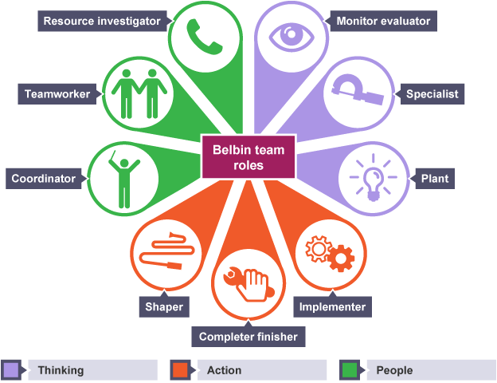

Source: {Dotnet}. Share (knowledge)

The role of Maslow

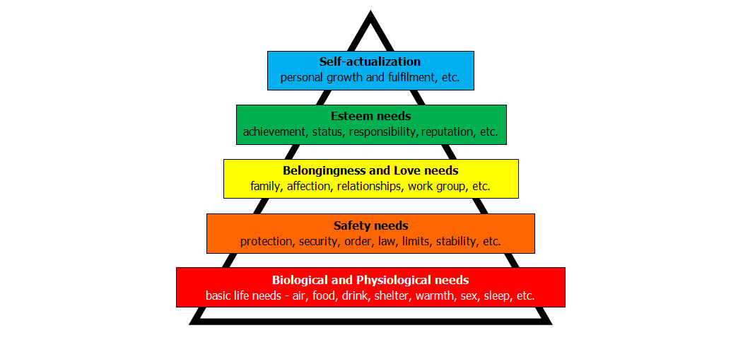
Image source: BytePerceptions

Maslow's Theory of Motivation: Driving Your Teams to Success

Many leaders fall into the trap of focussing on the deliverables/task before building the relationships and focussing on the people in the team.

They create a 'task culture' which may well achieve early success but a culture that isn't sustainable in terms of high performance.

Before long the team is in conflict, poor performance occurs and the team becomes affected by what is known as the 'dead body' syndrome. A terrible place where people come to to survive and do the bare minimum. You have 'attendees' rather than 'high performers'
As leaders we need to avoid the 'dead body' syndrome.

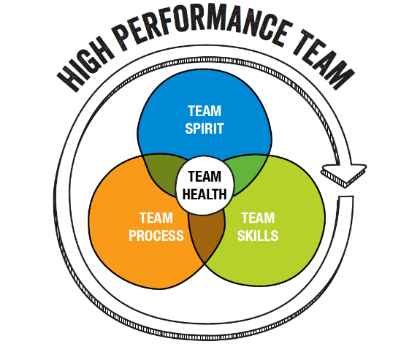
When you combine the individual and teams needs that's when performance takes off. You'll really start driving your team towards success and achieve outstanding results as a leader.

We need to create a place where everyone is striving to be the best they can be. Their physiological needs are met, they feel safe, loved, belong to something special, they are proud, confident and have high esteem. A place where the team has a purpose, goals are clear and values aligned. A place where spirit, skills, process and health all combine to ensure the magic happens.


Action-centred Leadership by John Adair

A model for team leadership and management.

John Adair's simple Action-Centred Leadership model provides a great blueprint for leadership and the management of any team, group or organisation. Action Centred Leadership is also a simple leadership and management model, which makes it easy to remember and apply, and to adapt for your own situation.

Good managers and leaders should have full command of the three main areas of the Action Centred Leadership model, and should be able to use each of the elements according to the situation. Being able to do all of these things, and keep the right balance, gets results, builds morale, improves quality, develops teams and productivity, and is the mark of a successful manager and leader.

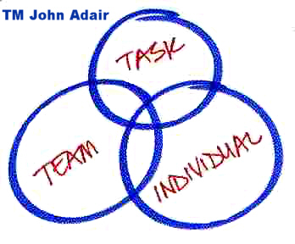
Source: The overlapping three-circle Action-Centred Leadership logo is a trademark of John Adair.

The model

The three parts of Adair's Action-Centred Leadership model are commonly represented by three overlapping circles, which is a trademark belonging to John Adair, and used here with his permission. Adair's famous 'three circles' model is one of the most recognisable and iconic symbols within management theory. When you refer to this diagram for teaching and training purposes please attribute it to John Adair, and help preserve the integrity and origins of this excellent model.

John Adair's Action-Centred Leadership model is represented by Adair's 'three circles' diagram, which illustrates Adair's three core management responsibilities:

- achieving the task
- managing the team or group
- managing individuals

John Adair, born 1934, British, developed his Action Centred Leadership model while lecturing at Sandhurst Royal Military Academy and as assistant director and head of leadership department at The Industrial Society. This would have been during the 1960s and 70s, so in terms of management theories, Adair's work is relatively recent.

His work certainly encompasses and endorses much of the previous thinking on human needs and motivation by Maslow, Herzberg and Fayol, and his theory adds an elegant and simple additional organisational dimension to these earlier works. Very importantly, Adair was probably the first to demonstrate that leadership is a trainable, transferable skill, rather than it being an exclusively inborn ability.

He helped change perception of management to encompass leadership, to include associated abilities of decision-making, communication and time-management. As well as developing the Action Centred Leadership model, Adair has written over 40 books on management and leadership, including Effective Leadership, Not Bosses but Leaders, and Great Leaders.

Leadership is different to management. All leaders are not necessarily great managers, but the best leaders will possess good management skills. One skill-set does not automatically imply the other will be present.

Adair used the original word meanings to emphasise this: Leadership is an ancient ability about deciding direction, from an Anglo-Saxon word meaning the road or path ahead; knowing the next step and then taking others with you to it. Managing is a later concept, from Latin 'manus', meaning hand, and more associated with handling a system or machine of some kind. The original concept of managing began in the 19th century when engineers and accountants started to become entrepreneurs.

There are valuable elements of management not necessarily found in leadership, e.g administration and managing resources. Leadership, on the other hand, contains elements not necessarily found in management, e.g inspiring others through the leader's own enthusiasm and commitment.

The Action Centred Leadership model is Adair's best-known work, in which the three elements - Achieving the Task, Developing the Team and Developing Individuals - are mutually dependent, as well as being separately essential to the overall leadership role.

Source: BusinessBalls

©John Adair action-centred leadership concept, Alan Chapman review and summary 2000-2012.

Tuckman Forming-Storming-Norming-Performing Model

Bruce Tuckman's 1965 Team-Development Model

Dr Bruce Tuckman published his Forming Storming Norming Performing model in 1965. He added a fifth stage, Adjourning, in the 1970s. The Forming Storming Norming Performing theory is an elegant and helpful explanation of team development and behaviour (US spelling: behaviour). Similarities can be seen with other models, such as Tannenbaum and Schmidt Continuum and especially with Hersey and Blanchard's Situational Leadership® model, developed about the same time.

Tuckman's model explains that as the team develops maturity and ability, relationships establish, and the leader changes leadership style. Beginning with a directing style, moving through coaching, then participating, finishing delegating and almost detached
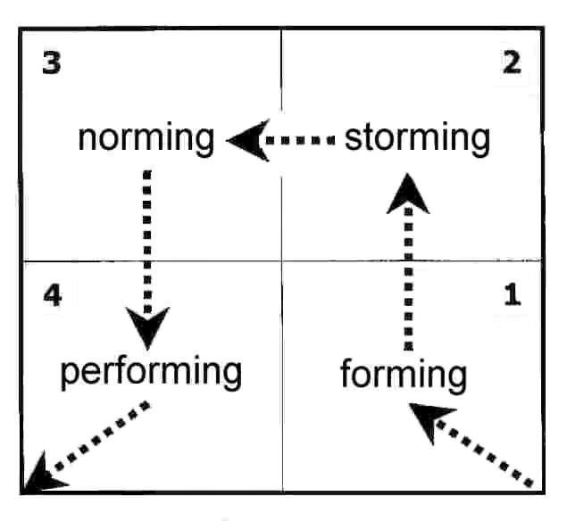
© Bruce Tuckman 1965 original 'Forming-storming-norming-performing' concept; Alan Chapman 2001-2013 review and code.

Four Stages

The progression is:

- forming
- storming
- norming
- performing

Here are the features of each phase:

Stage 1: forming
High dependence on leader for guidance and direction. Little agreement on team aims other than received from leader. Individual roles and responsibilities are unclear. Leader must be prepared to answer lots of questions about the team's purpose, objectives and external relationships. Processes are often ignored. Members test tolerance of system and leader. Leader directs (similar to Situational Leadership® 'Telling' mode).

Stage 2: storming
Decisions don't come easily within group. Team members vie for position as they attempt to establish themselves in relation to other team members and the leader, who might receive challenges from team members. Clarity of purpose increases but plenty of uncertainties persist. Cliques and factions form and there may be power struggles. The team needs to be focused on its goals to avoid becoming distracted by relationships and emotional issues. Compromises may be required to enable progress. Leader coaches (similar to Situational Leadership® 'Selling' mode).

Stage 3: norming
Agreement and consensus largely forms among the team, who respond well to facilitation by leader. Roles and responsibilities are clear and accepted. Big decisions are made by group agreement. Smaller decisions may be delegated to individuals or small teams within group. Commitment and unity is strong. The team may engage in fun and social activities. The team discusses and develops its processes and working style. There is general respect for the leader and some of leadership is more shared by the team. Leader facilitates and enables (similar to the Situational Leadership® 'Participating' mode).

Stage 4: performing
The team is more strategically aware; the team knows clearly why it is doing what it is doing. The team has a shared vision and is able to stand on its own feet with no interference or participation from the leader. There is a focus on over-achieving goals, and the team makes most of the decisions against criteria agreed with the leader. The team has a high degree of autonomy. Disagreements occur but now they are resolved within the team positively, and necessary changes to processes and structure are made by the team. The team is able to work towards achieving the goal, and also to attend to relationship, style and process issues along the way. Team members look after each other. The team requires delegated tasks and projects from the leader. The team does not need to be instructed or assisted. Team members might ask for assistance from the leader with personal and interpersonal development. Leader delegates and oversees (similar to the Situational Leadership® 'Delegating' mode).

Stage 5: adjourning
Bruce Tuckman refined his theory around 1975 and added a fifth stage to the Forming Storming Norming Performing model - he called it Adjourning, which is also referred to as Deforming and Mourning. Adjourning is arguably more of an adjunct to the original four stage model rather than an extension - it views the group from a perspective beyond the purpose of the first four stages. The Adjourning phase is certainly very relevant to the people in the group and their well-being, but not to the main task of managing and developing a team, which is clearly central to the original four stages.

Tuckman's fifth stage, Adjourning, is the break-up of the group, hopefully when the task is completed successfully, its purpose fulfilled; everyone can move on to new things, feeling good about what's been achieved. From an organisational perspective, recognition of and sensitivity to people's vulnerabilities in Tuckman's fifth stage is helpful, particularly if members of the group have been closely bonded and feel a sense of insecurity or threat from this change. Feelings of insecurity would be natural for people with high 'steadiness' attributes (as regards the 'four temperaments' or DiSC model) and with strong routine and empathy style (as regards the Benziger thinking styles model, right and left basal brain dominance).

Source: BusinessBalls

From your understanding of what is a theory, critique the works of Belbin, Maslow, Adair and Tuckman. Present back your critique to the class.

When reading about a theory or a model, find out:

- What are the origins of the theory / model:
a. What issue does it seek to explain?
b. Who developed the theory / model?
c. What are its origins? Did it develop out of another model or theory?
d. How it has changed/evolved over time?
e. What are the principles on which it is based?

- What are the strengths of this theory or model for understanding the topic:
a. What new explanations / insights does it offer?
b. What contribution does it make to understanding of issue?

- What are key criticisms of theory or model:
- What are its limitations and / or gaps?

- What other theory or model may be important in understanding this issue? Is this theory or model more, less or equally important in improving understanding of issue?

So what?
- In what way is this theory or model relevant to the context of the module?
- What are the implications of this theory, or model for practice?
- How can it be applied usefully to enhance practice?
Source: Glasgow Caledonian University


transactional vs. transformational leadership

There is no one blue print for making a great leader
Are all leaders created equal? No. Are there commonalities in the skills required to make great leaders of every age and stage? Yes. Are there important deliverables from different types of leadership styles? Yes. Do we need different things from our leaders as our career develops? Yes. Does that impact the different ways we are required to lead? Absolutely.
The environment we live in has never been more complex, volatile and unpredictable and I’d like to explore the difference in transactional leaders and transformational leaders – both vital to securing business success and complimentary to how they fit in the development function of our businesses, processes, and people. Transactional leaders leverage the most left-brain action of planning, organising, and efficiency while transformational leaders are best versed to visualise and articulate the strategy.
Both types of leadership must go hand in hand and there is a constant balancing act for us to be able to provide the right ingredients for growth, innovation an opportunity. There are arguably many different approaches to the ‘why and where for’ of the differences between both. Here’s a summary describing each style and an interesting comparison i read on boundless.com recently.

Transactional leadership
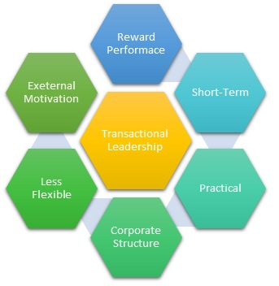
Image source: MBA Skool
Transactional leadership promotes compliance with existing organisational goals and performance expectations through supervision and the use of rewards and punishments. Transactional leaders are task- and outcome-oriented. Especially effective under strict time and resource constraints and in highly-specified projects, this approach adheres to the status quo and employs a form of management that pays close attention to how employees perform their tasks.
Transformational leadership
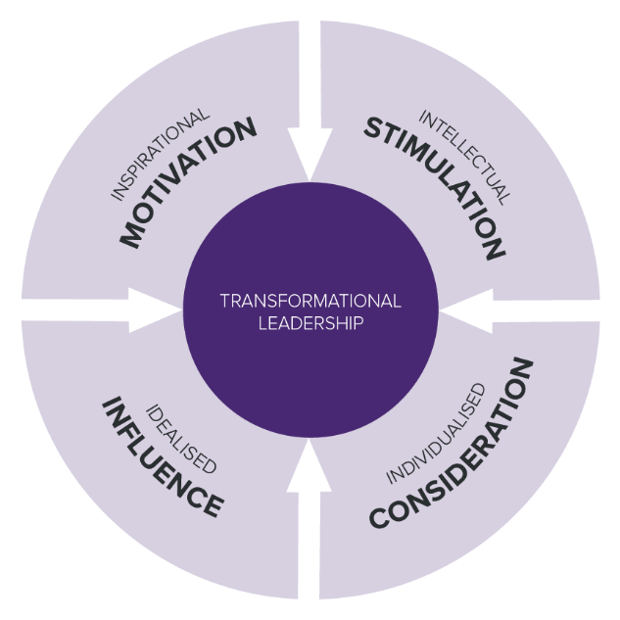
Image source: Codeburst.Io
Transformational leadership focuses on increasing employee motivation and engagement and attempts to link employees’ sense of self with organisational values. This leadership style emphasises leading by example, so followers can identify with the leader’s vision and values. A transformational approach focuses on individual strengths and weaknesses of employees and on enhancing their capabilities and their commitment to organisational goals, often by seeking their buy-in for decisions.
Comparing leadership types
Transactional and transformational leadership exhibit five key differences:
Transactional leadership reacts to problems as they arise, whereas transformational leadership is more likely to address issues before they become problematic.
Transactional leaders work within existing an organisational culture, while transformational leaders emphasise new ideas and thereby “transform” organisational culture.
Transactional leaders reward and punish in traditional ways according to organisational standards; transformational leaders attempt to achieve positive results from employees by keeping them invested in projects, leading to an internal, high-order reward system.
Transactional leaders appeal to the self-interest of employees who seek out rewards for themselves, in contrast to transformational leaders, who appeal to group interests and notions of organisational success.
Transactional leadership is more akin to the common notions of management, whereas transformational leadership adheres more closely to what is colloquially referred to as leadership.
Source: Boundless. “transactional versus transformational leaders.” Boundless management.
Helen Clarks recent interview for the UN secretary-general candidates debate was an exceptional example of a transformational leader. Helen clearly articulated her vision for the UN, her strengths that complement the values of the organisation and rationale pragmatic approaches to the challenges the UN faces. Her organisation might be the UN, but her stakeholders are every man, woman and child – she took us all on the journey of inspiration that would drive her success should she be appointed.
Strategy + Business: Find Your Strategic Leaders – 34.04 mins
https://youtu.be/l0UWBn-XPl4

Source: IMNZ

2 Kiwi examples of transformational leadership
Change doesn't happen without a vision and dedicated people working to achieve goals, something that transformational leadership can help with.
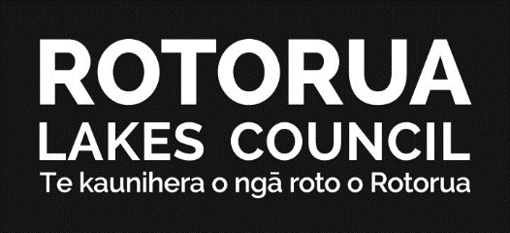
Back in 2013, Rotorua Council, along with prominent business and community leaders, acknowledged that negative perceptions of rotorua were having an adverse impact on the city's brand. Growing disparity within the community meant crime and safety issues were on the rise. Additionally, the number of vacant shops in the cbd further contributed to its depressed image.
Image source: RotoruaLakesCouncil
Recognising the need for change, Rotorua Mayor, Hon Steve Chadwick JP, took a new vector of approach.
"Let's recreate ourselves. Let's define a new attitude that expresses pride and a sense of place and purpose. Let's make this city buzz with excitement and expectation," he said.
The draft revitalisation strategy for rotorua was approved by the council in 2014, and has seen multi-million dollar projects begin to reinvigorate the city. It will take a while, but the tourism town is on its way to become a better, more livable city.
Air New Zealand's change of fortune
At the turn of the century Air New Zealand announced a net loss of around $360 million for the quarter ending september. This was a direct result of what the treasury and ministry of transport called "adverse business conditions and structural problems with its recent acquisition of ansett."

Image source: Wikipedia Commons

15 years on, the airline has a reputation for engaging employees, driving innovation, and a highly personable brand. It's a direct consequence of a drastic shift in philosophy; rather than simply flying planes, Air New Zealand knows it flies people.
Through its transformation, Air New Zealand now reflects customer centricity across the entire brand, which has helped make the New Zealand national carrier one of the most profitable organisations in the country
What do these examples have in common?
So what links these two case studies? The answer is transformational leadership.
This year, pwc published a report of insights into transformation. In this document leaders are urged to think beyond technological transformation, focusing on the benefits to people instead. Pwc suggests the following seven points are the key to effective transformation:

- At the core of successful transformation is excellent leadership.
- People need to be at the heart of change.
- Awareness and talking isn't enough, action is required.
- The journey of transformation is as important as reaching the end goal.
- Technology needs to be utilised as a positive force, not a distraction.
- Stakeholders can be a helpful driver of change.
- There is no use in doing business now if there's no vision for the future.
Comparing the changes undergone by the city of Rotorua and Air New Zealand to the report's findings, it's evident that both examples follow these principles. Neither Rotorua nor Air New Zealand shied away from involving various stakeholders in the process of planning and implementing the required changes. Leadership teams took action to guide their organisations through change. And, importantly, there was and is a clear vision for the future in place, which serves as a roadmap and motivator.
Why transformation is important
Organisations across the country face similar problems when it comes to how change is approached. The business performance innovation network summarises the main reasons for change into three issues:
- Organisational silos.
- Resistance to change.
- Disengaged staff.
The prevalence of top-down thinking inherently stands in the way of efficient innovation and transformation. However, without strong leadership pushing for action and supporting the workforce to get involved, there is little chance of actual change happening.
This resistance directly contradicts the notion of organisational metamorphosis. Without shaking up the way leadership and decision-making processes are approaches, progress is unlikely.
According to gallup, only 13 per cent of global employees are engaged and while New Zealand's figures are slightly better, there is room for improvement. Why? Because its research shows increased levels of engagement add to productivity. It is crucial, then, to ensure that employees and leaders alike take accountability for organisational change processes.
What does this mean for me?
If your organisation needs to change, one of the most effective ways to action this is through transformational leadership. To do so, leaders need to engage with the following:
- Involve employees in creating new structures. Getting feedback and asking staff to take ownership of the company's success has the dual benefit of improving engagement levels and transforming your business.
- Improve processes. To do this you need to take a step back and view the big picture, assess what needs to be changed and implement changes. The more streamlined processes are, the more effective your operation, which means long-term profits are more likely.
- Lead by example. If a leader doesn't embrace change, how can you expect employees to do so?
Leaders looking to make a positive change within their organisation therefore need to think holistically, keeping in mind the benefit that change will bring to people – something that both Rotorua and Air New Zealand have successfully done.
Bill Gate’s transactional leadership style
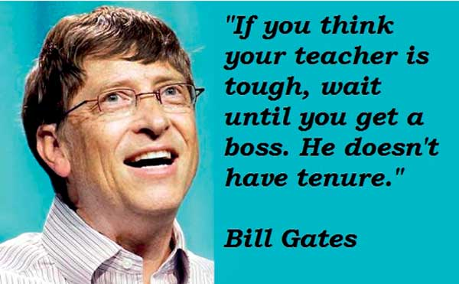
Leadership is a process by which a person influences others to accomplish an objective and directs the organisation in a way that makes it more cohesive and coherent.
To be successful, to realise business objectives, leaders carry out this process continuously and consistently by applying their knowledge, skills and appropriate leadership styles to be in line with the organisational maturity level and industry dynamics.
Influential leader
Bill Gates can be described in many ways – billionaire philanthropist, computer tycoon, astute predictor of future technology so on and so forth. He is more than just the world richest man; an influential leader transformed the whole world.
Early on his life, Bill Gates inherited the ambition, intelligence, and competitive spirit that had helped him to rise to the top. Under his leadership, Microsoft revolutionised IT industry and became one of the most important trendsetters in the modern world. In this analysis we will be discussing an important façade of his leadership style during initial stages of Microsoft – “Transactional Leadership”.
From creating Microsoft in 1975 until 2006, Gates had primary responsibility for the company’s product strategy. He aggressively broadened the company’s range of products, and wherever Microsoft achieved a dominant position he vigorously defended it. Bill was intensely focused and glued onto his target from his younger days –so much so - during early days at Microsoft, when he programmed-he’d sit with a marker clenched in his mouth, tapping his feet and rocking, impervious to distraction. It was an indication to see how Gates would someday maintain a razor-like focus on making Microsoft successful over decades.
Powerful and strict
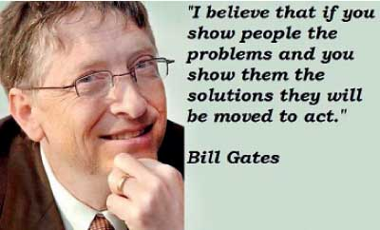
Bill Gates often presents himself as a powerful and strict leader to rivals and his subordinates. He has successfully transformed Microsoft into a stable monopoly. To maintain the company’s status, Gates had to focus on creating barriers to new entrants. Besides, he had to strictly control the organisation’s production process so that the products can be well accepted by consumers.

Both these situations require a leader’s toughness and task orientation on management. Bill Gates’ style will work better if the company is a monopolist, as rigid control and toughness on partners and subordinates can create difficulties to the survival of new entrants.

Initial stages
At the initial stages of Microsoft, focus was very much on accomplishment than comfort, well-being and continuity of the staff. For example - when Bill realised that Paul Allen’s (Microsoft Cofounder) contribution towards a start-up company (Microsoft) was not adequate (due to poor health of Allen) Bill was ruthless in side-lining Allen from the company.
Some argued that Microsoft was not a creative and innovative company. They were of the view that Bill Gates reformed existing products to satisfy markets needs instead of inventing something new. Microsoft was not just the market leader, but also the standards provider for the industry, some critics claimed that winning was so important to Gates that he would go to any extent to beat his competitor. With his aggressive business acumen, Gates has been in and out of courtrooms to deal with legal problems almost since Microsoft began. Many of the large technology companies have been legally against the actions of Microsoft, including -Opera, APPLE, NETSCAPE, Etc.
Bill Gates is not known for engaging or adaptive communication. Rather, he is well known to be rude, abrasive, and sometimes dismissive of others’ ideas. He once stated his hiring practice as, “I don’t hire bozos,” who will tell me how to run my business and demonstrated foresight in his hiring by actively selecting dedicated, hard-working individuals at the initial development stages of Microsoft. His task-oriented behaviour is evident on displayed strong personality attributes such as:
Focus
Bill Gates has demonstrated over nearly thirty years the importance of clarity of thought and execution unlike many of his contemporaries. Allen recalls meeting Gates in the late 1960s. He was a “freckle-faced eighth grader” at an old Teletype computer.
He was “really smart,” “really competitive,” and “really, really persistent.” says Allan. While his lack of interest in personal habits and social convention is legendary, the story of Gates’s first dinner with Allen and his girlfriend is priceless:” Did you see that?” she said after he’d left. “He ate his chicken with a spoon. I have never in my life seen anyone eat chicken with a spoon.” When Bill was thinking hard about something, he paid no heed to social convention.
Passion
Young Gates read Fortune magazine religiously, and once asked Allen, “What do you think it’s like to run a Fortune 500 company?” Already a budding entrepreneur at 13, Gates said maybe they’d have their own company together someday. “A computer on every desk and Microsoft software on every computer” – this was Bill’s vison for Microsoft. His philosophy was, if anything is worth doing, it is worth doing well. From a simple thank you note to a complex proposal it is critical to place the stamp of excellence on whatever one undertakes.
Confrontational taskmaster
Microsoft was a high-stress environment because Bill drove others as hard as he drove himself. He was growing into the taskmaster who would prowl the parking lot on weekends to see who’d made it in. People were already busting their tails, and it got under their skin when Bill hectored them into doing more.
Bill liked to hash things out in intense, one-on-one discussions; he thrived on conflict and wasn’t shy about instigating it. Being a task-oriented leader, he helped the team understand their goal by providing a series of steps that structure their initial meetings. He said, “I believe that if you show people the problems and if you show them the solutions they will be moved to act”.
At an interview, Apple co-founder Steve Wozniak said Steve Jobs had “a very futuristic forward vision, almost a bit of the science fiction, ‘Here’s what life could be,’ but Bill Gates had more of an execution ability to build the things that are needed now, to build a company now, make the profits now, in the short-term.
“You really need the vision like Steve Jobs had, but the vision doesn’t go anywhere if you try to jump in and build products before they are cost effective for what they do, return on investment is there, that’s where Bill Gates was brilliant” he said.
Throughout the growth stages of Microsoft, Bill’s dominance on transactional leadership style contributed towards phenomenal growth of the organisation endorsing there is a time and place for transactional leadership style to be successful.
Source: Daily Mirror

Research and present back the strengths and weaknesses of each approach. Which leadership style is more effective? And why? Where possible, give industry leaders to support your answer.


executive leadership teams (ELT) why have them?
Executive teams play 2 critical roles in an organisation.
The first is obvious — they provide strategic and operational leadership to the company. They set goals, develop strategy, and ensure the strategy is executed effectively.


The second is less obvious, but just as important — the executive team provides the organisational and cultural DNA for the company. How well the executive team functions as a collective leadership body and how its members interact serves as the model that teams throughout the organisation will follow.
Executive Team Effectiveness
You could fill entire libraries with the books and studies written about strategy and operations. The second role of the executive team, though, gets less press. Because it receives relatively little attention, team effectiveness can be the basis of a significant competitive advantage for companies.
In our recent survey of senior executives, 65% indicated their executive teams were experiencing a clash between functional and enterprise accountabilities. But fewer than 1 in 5 rated their executive teams as “very effective.”
Nearly all executives surveyed agreed that “increased effectiveness of my executive team will have a positive impact on organisational results.”
In other words, when the executive team functions better, the whole organisation functions better.
The Best Executive Teams Have These 3 Things
The best executive teams are characterised by 3 vital threads that run through everything they do.
- Strategic focus. Effective executive teams establish a vision for the organisation and invest considerable time and energy at the strategic level. They balance risk and innovation, anticipate future needs and opportunities, and seek to ensure the organisation’s sustainability.
- Collective approach. Top-performing executive teams work together, taking an enterprise-wide view of their individual and team functions. They model for the entire organisation ways to break down silos and develop solutions to business problems together. Individuals on top-performing executive teams prioritise the interests of the organisation over individual gains.
- Team interaction. Finally, the best executive teams are intentional in their interactions. They value their differences, listen and communicate well, seek input from each other, and trust and respect one another. These behaviours make teams more effective. Crucially, they also model for the rest of the enterprise what team interactions should look like.

How to Build a High-Performing Executive Team
Part of every CEO’s job description should be to “build and develop a world-class executive team.” This is challenging, because the qualities that typically earn senior executives a place on the executive team are necessary, but not sufficient, for peak performance on that team.
So how does one build a highly effective executive team? There are 5 keys:
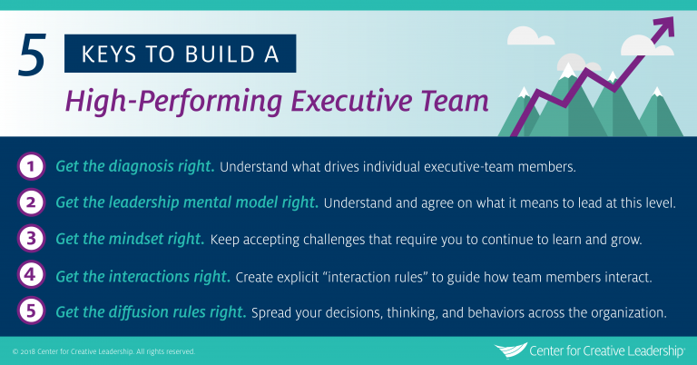
- Get the diagnosis right. The CEO or top leader at an organisation should understand what drives individual executive-team members and what makes them work — or not — as a group.
- Get the leadership mental model right. Executive team members must have an explicit understanding of, and agreement with, what it means to lead at the enterprise level. Senior executives must understand that their role on the team goes beyond functional responsibilities.
- Get the mindset right. For seasoned leaders, the executive team shouldn’t represent the summit of their professional development, but rather a new challenge that requires them to continue to learn and grow. They must also bring this perspective to their direct reports and others they interact with, encouraging them to develop beyond their technical expertise.
- Get the interactions right. Creating explicit “interaction rules” to guide how team members interact with one another is critical to building effective teams. Members of the executive team must be transparent, vulnerable, and comfortable learning in public; they must also have strong communication skills.
- Get the diffusion rules right. Finally, executive teams are only effective when their decisions, thinking, and behaviours can spread quickly across large numbers of people at all levels of the organisation. This ensures that strong, healthy executive team actions and values can be modeled by other teams throughout the enterprise.
Source: Centre for Creative Leadership
Choose any mid-to-large tourism or hospitality organisation and research if they have an Executive Leadership Team (ELT). To give you an example, click on the following link:

Tourism Holdings Limited (thl): thl Executive Team: http://www.thlonline.com/AboutTHL/Pages/ExecutiveTeam.aspx
The team is made up of the Chief Executive Officer, the Chief Operating Officer and the Chief Financial Officer.
- What skills do these senior professionals have?
- What qualifications do they possess?
- What’s their background? How many years experience do they have?
- What symbol do they have beside their job title?
- What do you think makes them a leader?
- Why do you think they are on the Executive Team?

the leadership circle
Accroding to The New Zealand Council for Educational Research (NZCER), The Leadership Circle is the synthesis of decades of leadership development and practices, resulting in a unique and powerful framework that connects leaders with the information they need to discover what is and isn't working. This reveals which thoughts and actions are driving success, and which may be undermining their effectiveness, illuminating opportunities for leadership development.
The Leadership Circle assessment and development tools are available in NZ exclusively through NZCER to certified consultants. We also regularly run certification workshops for leadership/executive coaches and consultants who wish to incorporate The Leadership Circle framework into their practice.
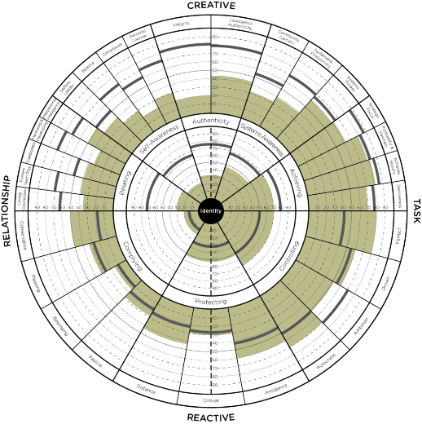
Image source: Transformative Insights
Transformative Insights & The Leadership Circle
The Leadership Circle is a powerful leadership development framework, which includes the Leadership Culture Survey™ and Leadership Circle Profile™.
These 360 degree assessments reveal to leadership teams their current versus desired collective leadership culture and provide individual leaders deep insight into their leadership effectiveness and clear pathways for lifting their leadership to a higher level.
Ideally suited for leadership teams as well as individual, emerging and experienced, leaders and managers at all levels, it is a framework that provides incredible rich information that enables transformational change in leadership effectiveness.
The Leadership Circle Profile - for individual leaders
The Leadership Circle Profile is designed to accelerate leadership effectiveness beyond traditional competency-based approaches. When it comes to developing leaders, training to competencies alone does not work very well. For more rapid and lasting results, it is crucial that organisations help leaders gain deeper insight into their behaviour and what is driving it.
The Leadership Circle Profile™ is the only 360 degree competency assessment that simultaneously provides focused competency feedback while revealing the underlying assumptions that are causing a leader’s pattern of strengths and limitations. The Leadership Circle Profile helps leaders understand the relationship between how they habitually think, how they behave, and, more importantly, how all this impacts their current level of leadership effectiveness. Once this awareness is established, leadership development can proceed. Without it, change rarely happens.
The Leadership Circle Model – 3.35mins
https://youtu.be/QMWYiAgg1dc
The Leadership Culture Survey - for leadership teams
Effective leadership outperforms ineffective leadership, which is why we think leadership is a primary competitive advantage and strategic priority. The effectiveness of the leadership system in an organisation determines, to a large degree, the organisation’s performance, especially in volatile and uncertain business environments.
Now there is an assessment that measures the health of your leadership system—the culture of leadership in your organisation. The Leadership Culture Survey is the most comprehensive assessment available on the overall health and effectiveness of the leadership in your organisation.
The Leadership Culture Survey provides a powerful “MRI” of your leadership culture. Used for your entire organisation, or just a leadership team, the Leadership Culture Survey reveals valuable data, tells you how your people view their current leadership culture, and compares that reality to the optimal culture they desire. The “gap” between the current culture and desired culture, instantly reveals key opportunities for leadership development. The Leadership Culture Survey also measures how your leadership culture compares to that of other organisations.

effective leadership capabilities
American Express has a piece on their website about leadership styles and in particular, ‘what’s your most effective leadership style?’And how can certain types of leadership style help determine where you fall on the spectrum.
So what does it take to be a great leader? Six business owners share what they think effective leadership looks like?
When people have conversations about great leaders, there are names that always come to mind: Steve Jobs, Richard Branson, the latest TED-talker du jour... Everyone has an idea of a great leader they would add to the list. But what makes these people so great? Is it their effective leadership skills, their vision, their drive?
I sat down with six leaders in their own right, those tasked with the day-to-day of helping create these leadership legends. They each shared their thoughts on what effective leadership looks like to them, which may help you amp up your own or even your company’s leadership level of awesome.
Effective Leadership Calls for Working Through Fear
Carey Lohrenz is the CEO of Carey Lohrenz Enterprises, a fighter pilot (the first female F-14 Tomcat Fighter Pilot in the U.S. Navy, to be exact) and the author of Fearless Leadership: High Performance Lessons from the Flight Deck. Lohrenz is also a leadership consultant and keynote speaker for top Fortune 500 companies, helping them build high-performing teams. She says:
“The best leaders are those who can work through fear and do what needs to be done in spite of that fear. Great leaders set a clear vision for their team that both inspires and aligns the team, while staring fear, uncertainty and discomfort in the face. They aren’t content to rest on their laurels—ever. And they don’t make excuses about why they can’t take the next step forward on their leadership journey.”
Be Better for Everyone
Leadership coach John Michael Morgan is known for his high energy and passion when teaching proven strategies designed to help achievers reach their goals. He’s the founder of The Achievers Alliance, a personal development coaching program designed to equip leaders and entrepreneurs with the tools they need to achieve success. He had this to say about effective leadership:
“Great leaders understand that nothing improves until you improve. If you want your team to be better, you must be better. Improvement in results starts with improvement in yourself. Spend more time working on yourself than your team and you'll be equipped to lead them to success.”
Learning Never Stops
Marc A. Pittman, CEO of Concord Leadership Group, which helps nonprofit executives and board members navigate leadership and funding issues in their organisations, believes effective leadership is that which pushes people to continue learning.
“Great leaders have a surprising blend of humility and nerve. They are humble enough to know they don't know it all. So they are lifelong learners who encourage the people around them to continue learning and growing too. But great leaders also have the nerve to make decisions and take action. Even when they know they won't please everyone. This risk-taking chutzpah can sometimes surprise people, but nothing would get accomplished without it. And because great leaders are humble enough to invest in the growth of people around them, their risk-taking nerve tends to not burn relationships with the people they lead.”
“Great leaders understand that nothing improves until you improve. If you want your team to be better, you must be better.”
—John Michael Morgan, founder, The Achievers Alliance
It's About Empowering, Not Directing
Robert Rose is the Chief Strategy Advisor for the Content Marketing Institute. His role is to help marketers tell their story more effectively through digital media. Over the last five years, Rose has worked with more than 500 companies of all sizes, including 15 of the Fortune 100. He’s provided strategic marketing advice and counsel for global brands such as Capital One, Dell, Caterpillar, Hewlett Packard, Microsoft and UPS. For Rose, effective leadership can be broken down into three traits.
“The first is they demonstrate that they use their position to provide safety. They instill confidence in the ability for teams to be creative, take risks and communicate truthfully without fear. The second is that great leaders rarely direct, as much as empower others to self-organise and activate. The effective leader doesn’t have followers, she has other leaders for whom she clears the way. Third, but perhaps most importantly, great leaders have an innate ability to foster a sense of belonging. When this is fully realised, it's not simply creating a sense of shared purpose in each individual, but rather it is when each individual realises, and more importantly cares, why everyone on the team matters.”
The Nonverbal Cues of Great Leaders
Mark Bowden is widely recognised as one of the world’s foremost authorities on nonverbal communication. As founder of TRUTHPLANE, Bowden trains groups and individuals on how to use their body language to stand out, win trust and gain credibility every time they communicate. His clients include presidents and CEOs of Fortune 500 companies and prime ministers of G8 powers. Bowden believes nonverbal cues are just as important to effective leadership as the aforementioned qualities.
“As social mammals, we humans have an instinct for organising into groups to increase survival. These groups have leaders. We have a simple system for quickly working out which of us might be a great leader: first we look for who is calm and assertive. We gauge this through rhythms of movement. If another’s actions are deliberate, direct and give a clear result, then it triggers a sense of “benefit” around them.
Next, we look to see if they control valuable resources. This can be predicted from the amounts of space they occupy. We look to see if they maximise or minimise their territory—are they expansive or contracted in their gestures. Finally, we take stock of how consistent these behaviours are. We look for evidence that these calm, assertive and expansive behaviours are not just one-off events but show up repeatedly. Through all of this, we make assumptions that another is trustworthy, credible and followable—and we can make these calculations in seconds. That’s why some people just “feel” like a great leader to us, even before they have uttered a single word.”
Take People Where They Need to Go
Christopher S. Penn of SHIFT Communications is an authority on digital marketing and marketing technology. A recognised thought leader, author and speaker, he has shaped three key fields in the marketing industry: Google Analytics adoption, data-driven marketing and PR and email marketing. Known for his high-octane, here’s-how-to-get-it-done approach, his expertise benefits companies such as Citrix Systems, McDonald’s, GoDaddy and McKesson. Effective leadership is about providing others with motivation, he says.
“A poor leader doesn’t take us anywhere, or takes us in the wrong direction.
A good leader takes us where we want to go.
A great leader takes us where we need to go.
The best leaders convince us to lead with them.
As with all journeys, we need the means to get there, a legitimate opportunity to make the journey, and the motivation to open the door and take the first step. A great leader provides us the motivation. We have to look for the opportunity. Our businesses must provide the means.”
Below are some of the essential skills of leadership:
- Authenticity
- Good Communication
- Being Articulate
- Thinking On Your Feet
- Humour
- Flexibility
- Integrity
- Compelling Presence
- Empathy
Where in the above online article have these been applied? If you can’t find an example, think about how you can position these and how they can be applied to leadership.
SKILL SESSION
integrity & ethics
According to the job seeking website, Indeed, integrity is often seen as just truthfulness or honesty, but in many cases, it also means having and standing by a set of strong values. Integrity in the workplace often means being able to make ethical choices and helping the company maintain a positive image. All businesses seek to hire workers who have a strong sense of integrity.
Engaging Employees to Succeed at What? Integrity?
Kate Nasser, The People Skills Coach™ works with leaders on engaging employees. I’m always interested in how others are defining it and doing it. Today I read David Zinger’s definition: Employee Engagement: Good work, done well, with others, every day.
At the same time, I’m reading about Toyota’s and GM’s car safety issues and wonder if the employees thought they were engaged in good work done well. Most likely the answer is yes. Hence the confusion with employee engagement.
When leaders approach me about engaging employees, I ask them, engage employees to do what? Get the job done? Follow the leaders? Engage each other for company-wide success? Each answer leads to different results.
Engaging Employees: Culture of Accountability & Integrity
As the new CEO of GM fields questions about why the corporation didn’t fix known safety issues, she has focused on the problem of silos that stopped communication. However, …
Silos don’t stop communication.
Silos create communication challenges that a culture of accountability and integrity solves.
Supposedly at GM, departments that were aware of the trouble with ignition switches didn’t tell the engineering teams. Why not? Why wouldn’t they feel absolutely compelled to inform others who could solve the problem? Silos don’t explain this. Their cultural definition of employee engagement does.
Clearly, GM’s definition of engaging employees was limited to meeting department goals. The engagement culture was not one of company-wide accountability to protect customers and GM’s good name. What was missing?
The simple question that wasn’t on everyone’s mind …
Even established core values like the following don’t compel people to engage each other throughout a company.
Employees likely think of core values as applying to their own work not necessarily as calling them to engage each other for company success. Most core values lack this call to action.
Leaders, you can fill this gap by asking the following two questions consistently with your teams:
- Who does this issue impact?
- Who all needs to know?
Engage employees to engage each other for company-wide success!
If you want employees to do good work, done well, with others, every day, as David Zinger proposes, then live, model, and illustrate the phrase “with others”.
You will effectively develop a culture accountability and integrity that engages employees to engage each other. It will remove the communication challenges that silos create.
Source: Kate Nasser. The People Skills Coach™

Why is integrity important in leadership?

Why is integrity important in aligning to company values?
Your trainer will hand out an article for you to read. The content is strongly linked to integrity. Are companies ethical by investing in social media companies, such as Facebook, Google and Twitter?
Quality of a Leader – Integrity – Be True to Your Word
According to the Inspired Business Concepts website, “Integrity isn’t a value in itself, but it is a value that guarantees all the other values”. I believe that is quite true. In this instalment of the “quality of a leader” series, we will examine the idea of integrity. And for simplicity, I will define integrity as this, “be true to your word”.
The need for integrity in leadership cannot be overstated. Brian Tracy, founder of FocalPoint, says, “Integrity is the most required, the most respected and the most admired quality of superior people”. If you want to be respected as a leader, you have to be seen as a person of integrity.

Picture the Effective Leaders in Your Life by Inspired Business Concepts
So now it’s time to get a little creative.
Take a moment and think about the most effective leaders you have had the pleasure to meet in your life. These may be bosses, team leaders, pastors, scout leaders, coaches or mentors. Your relationship may have been professional, or personal. Take a moment and think about that person. Picture them in your mind.
Got them? Now, talk to your class about the attributes that made you think of them. While many different traits may come to mind, I would guess all of them would share this trait to some degree. I cannot imagine any leader that you would consider effective, any leader that you would respect, any leader that was a pleasure to serve, as being a leader that lacked integrity.
Source: Inspired Business Concepts

A Case Study
A manufacturing company producing travel and hospitality related products is located on the outskirts of a sparsely populated town. They provide many jobs for a lot of people where employment is not easy to find in the immediate suburb.
The company has managed to stay in the area, even though it could find cheaper workers elsewhere. Their workers are loyal to the company due to the jobs it provides. Over the years, the company has developed a reputation in the town for taking care of its employees and being a ‘responsible corporate citizen’.
The manufacturing process used by the company produces a by-product that for years, has been flowing into the town river. The by-product has been considered harmless, but some people who live near the river have reported illnesses. The by-product does not currently violate any anti-pollution laws. Have a discussion around the following points:
- What do you consider to be the issues of integrity and ethics posed in the case study?
- What options does the company have?
- What should it do and why?
Source: UNODC
The New Zealand Business Performance Panel
The Ministry of Business, Innovation and Employment in New Zealand has a section on the website dedicated to learning more about management and leadership skills.
He aha te mea nui o te āo? He tāngata, he tāngata, he tāngata.
What is the most important thing in the world? It is people, it is people, it is people.
- Māori proverb.
In order to fine tune the skills needed to become an effective leader, you need to focus on improving the following skills:
- Put your people first
- Fine tune your communication skills
- Make trust a priority
- Check that your practices are fair
- Use different leadership skills
- Motivate your employees
- Manage your people’s performance
- Have a plan for underperformance
- Shape your workplace culture

Create an infographic that highlights an overview/top tips of the above skills. What are the quick tips i.e. the Do’s and Don’t’s for each item that is listed on the previous page? Remember that your Infographic needs to look professional and articulate the salient points. Your infographic is an ideal opportunity to deliver material that can be shared via social media.

How to be a good leader
On the same website and using the following URL: https://bit.ly/2Q62SuK, have a go at completing a self-assessment on Trust and Fairness.
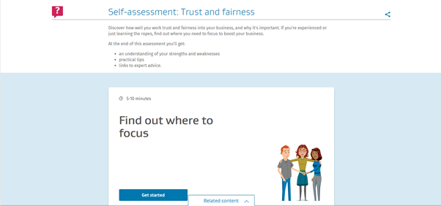
For those students who studied the Level 5 Hotel and Hospitality Management course, you may have come across the opportunity to read all about an overview of the various leadership styles and when to use them. For those who have not, here’s your chance to complete a quiz entitled “Which leadership style?” using the following URL: https://bit.ly/2y7aqUW
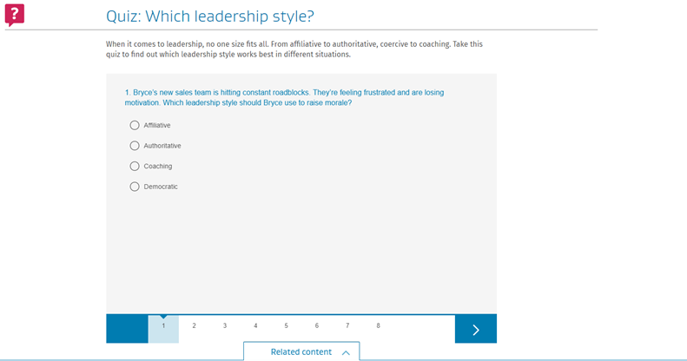
Have a good look around the website as there are some interesting case studies from a variety of sectors that places a strong emphasis on putting the theory into best and effective practice.

When it comes to organisational change, failure continues to be more common than success. In a survey of over 3000 leaders, McKinsey discovered the failure rate to be over 60% whilst Harvard Business Review’s research indicated the number of transformation efforts that fail is over 70%. Source: Blacksmith website
In the Harvard Business Review, one sentence states that
“Change management and leadership development programmes have a woeful record at most organisations.”
Why is this the case? And how can organisations become more successful at it?

the ten principles of change management
DeAnne Aguirre, senior partner with Strategy & Business, discusses techniques that can help companies transform quickly and effectively.
How to Lead Change Management – 4.49 mins
Https://Youtu.Be/Pq0dokfhecq
Way back when (pick your date), senior executives in large companies had a simple goal for themselves and their organisations: stability. Shareholders wanted little more than predictable earnings growth. Because so many markets were either closed or undeveloped, leaders could deliver on those expectations through annual exercises that offered only modest modifications to the strategic plan. Prices stayed in check; people stayed in their jobs; life was good.
Market transparency, labour mobility, global capital flows, and instantaneous communications have blown that comfortable scenario to smithereens. In most industries — and in almost all companies, from giants on down — heightened global competition has concentrated management’s collective mind on something that, in the past, it happily avoided: change. Successful companies, as Harvard Business School professor Rosabeth Moss Kanter told S+B in 1999, develop “a culture that just keeps moving all the time.”
This presents most senior executives with an unfamiliar challenge. In major transformations of large enterprises, they and their advisors conventionally focus their attention on devising the best strategic and tactical plans. But to succeed, they also must have an intimate understanding of the human side of change management — the alignment of the company’s culture, values, people, and behaviours — to encourage the desired results. Plans themselves do not capture value; value is realised only through the sustained, collective actions of the thousands — perhaps the tens of thousands — of employees who are responsible for designing, executing, and living with the changed environment.
Long-term structural transformation has four characteristics: scale (the change affects all or most of the organisation), magnitude (it involves significant alterations of the status quo), duration (it lasts for months, if not years), and strategic importance. Yet companies will reap the rewards only when change occurs at the level of the individual employee.
Many senior executives know this and worry about it. When asked what keeps them up at night, CEOs involved in transformation often say they are concerned about how the work force will react, how they can get their team to work together, and how they will be able to lead their people. They also worry about retaining their company’s unique values and sense of identity and about creating a culture of commitment and performance. Leadership teams that fail to plan for the human side of change often find themselves wondering why their best-laid plans have gone awry.
No single methodology fits every company, but there is a set of practices, tools, and techniques that can be adapted to a variety of situations. What follows is a “Top 10” list of guiding principles for change management. Using these as a systematic, comprehensive framework, executives can understand what to expect, how to manage their own personal change, and how to engage the entire organisation in the process.
1. Address the “human side” systematically. Any significant transformation creates “people issues.” New leaders will be asked to step up, jobs will be changed, new skills and capabilities must be developed, and employees will be uncertain and resistant. Dealing with these issues on a reactive, case-by-case basis puts speed, morale, and results at risk. A formal approach for managing change — beginning with the leadership team and then engaging key stakeholders and leaders — should be developed early and adapted often as change moves through the organisation. This demands as much data collection and analysis, planning, and implementation discipline as does a redesign of strategy, systems, or processes. The change-management approach should be fully integrated into program design and decision making, both informing and enabling strategic direction. It should be based on a realistic assessment of the organisation’s history, readiness, and capacity to change.
2. Start at the top. Because change is inherently unsettling for people at all levels of an organisation, when it is on the horizon, all eyes will turn to the CEO and the leadership team for strength, support, and direction. The leaders themselves must embrace the new approaches first, both to challenge and to motivate the rest of the institution. They must speak with one voice and model the desired behaviours. The executive team also needs to understand that, although its public face may be one of unity, it, too, is composed of individuals who are going through stressful times and need to be supported.
Executive teams that work well together are best positioned for success. They are aligned and committed to the direction of change, understand the culture and behaviours the changes intend to introduce, and can model those changes themselves. At one large transportation company, the senior team rolled out an initiative to improve the efficiency and performance of its corporate and field staff before addressing change issues at the officer level. The initiative realised initial cost savings but stalled as employees began to question the leadership team’s vision and commitment. Only after the leadership team went through the process of aligning and committing to the change initiative was the work force able to deliver downstream results.
3. Involve every layer. As transformation programs progress from defining strategy and setting targets to design and implementation, they affect different levels of the organisation. Change efforts must include plans for identifying leaders throughout the company and pushing responsibility for design and implementation down, so that change “cascades” through the organisation. At each layer of the organisation, the leaders who are identified and trained must be aligned to the company’s vision, equipped to execute their specific mission, and motivated to make change happen.
A major multiline insurer with consistently flat earnings decided to change performance and behaviour in preparation for going public. The company followed this “cascading leadership” methodology, training and supporting teams at each stage. First, 10 officers set the strategy, vision, and targets. Next, more than 60 senior executives and managers designed the core of the change initiative. Then 500 leaders from the field drove implementation. The structure remained in place throughout the change program, which doubled the company’s earnings far ahead of schedule. This approach is also a superb way for a company to identify its next generation of leadership.
4. Make the formal case. Individuals are inherently rational and will question to what extent change is needed, whether the company is headed in the right direction, and whether they want to commit personally to making change happen. They will look to the leadership for answers. The articulation of a formal case for change and the creation of a written vision statement are invaluable opportunities to create or compel leadership-team alignment.
Three steps should be followed in developing the case: First, confront reality and articulate a convincing need for change. Second, demonstrate faith that the company has a viable future and the leadership to get there. Finally, provide a road map to guide behaviour and decision making. Leaders must then customise this message for various internal audiences, describing the pending change in terms that matter to the individuals.
A consumer packaged-goods company experiencing years of steadily declining earnings determined that it needed to significantly restructure its operations — instituting, among other things, a 30 percent work force reduction — to remain competitive. In a series of offsite meetings, the executive team built a brutally honest business case that downsizing was the only way to keep the business viable and drew on the company’s proud heritage to craft a compelling vision to lead the company forward. By confronting reality and helping employees understand the necessity for change, leaders were able to motivate the organisation to follow the new direction in the midst of the largest downsizing in the company’s history. Instead of being shell-shocked and demoralised, those who stayed felt a renewed resolve to help the enterprise advance.
5. Create ownership. Leaders of large change programs must overperform during the transformation and be the zealots who create a critical mass among the work force in favour of change. This requires more than mere buy-in or passive agreement that the direction of change is acceptable. It demands ownership by leaders willing to accept responsibility for making change happen in all of the areas they influence or control. Ownership is often best created by involving people in identifying problems and crafting solutions. It is reinforced by incentives and rewards. These can be tangible (for example, financial compensation) or psychological (for example, camaraderie and a sense of shared destiny).
At a large health-care organisation that was moving to a shared-services model for administrative support, the first department to create detailed designs for the new organisation was human resources. Its personnel worked with advisors in cross-functional teams for more than six months. But as the designs were being finalised, top departmental executives began to resist the move to implementation. While agreeing that the work was top-notch, the executives realised they hadn’t invested enough individual time in the design process to feel the ownership required to begin implementation. On the basis of their feedback, the process was modified to include a “deep dive.” The departmental executives worked with the design teams to learn more and get further exposure to changes that would occur. This was the turning point; the transition then happened quickly. It also created a forum for top executives to work as a team, creating a sense of alignment and unity that the group hadn’t felt before.
6. Communicate the message. Too often, change leaders make the mistake of believing that others understand the issues, feel the need to change, and see the new direction as clearly as they do. The best change programs reinforce core messages through regular, timely advice that is both inspirational and practicable. Communications flow in from the bottom and out from the top and are targeted to provide employees the right information at the right time and to solicit their input and feedback. Often this will require overcommunication through multiple, redundant channels.
In the late 1990s, the commissioner of the Internal Revenue Service, Charles O. Rossotti, had a vision: The IRS could treat taxpayers as customers and turn a feared bureaucracy into a world-class service organisation. Getting more than 100,000 employees to think and act differently required more than just systems redesign and process change. IRS leadership designed and executed an ambitious communications program including daily voice mails from the commissioner and his top staff, training sessions, videotapes, newsletters, and town hall meetings that continued through the transformation. Timely, constant, practical communication was at the heart of the program, which brought the IRS’s customer ratings from the lowest in various surveys to its current ranking above the likes of McDonald’s and most airlines.
7. Assess the cultural landscape. Successful change programs pick up speed and intensity as they cascade down, making it critically important that leaders understand and account for culture and behaviours at each level of the organisation. Companies often make the mistake of assessing culture either too late or not at all. Thorough cultural diagnostics can assess organisational readiness to change, bring major problems to the surface, identify conflicts, and define factors that can recognise and influence sources of leadership and resistance. These diagnostics identify the core values, beliefs, behaviours, and perceptions that must be taken into account for successful change to occur. They serve as the common baseline for designing essential change elements, such as the new corporate vision, and building the infrastructure and programs needed to drive change.
8. Address culture explicitly. Once the culture is understood, it should be addressed as thoroughly as any other area in a change program. Leaders should be explicit about the culture and underlying behaviours that will best support the new way of doing business and find opportunities to model and reward those behaviours. This requires developing a baseline, defining an explicit end-state or desired culture, and devising detailed plans to make the transition.
Company culture is an amalgam of shared history, explicit values and beliefs, and common attitudes and behaviours. Change programs can involve creating a culture (in new companies or those built through multiple acquisitions), combining cultures (in mergers or acquisitions of large companies), or reinforcing cultures (in, say, long-established consumer goods or manufacturing companies). Understanding that all companies have a cultural centre — the locus of thought, activity, influence, or personal identification — is often an effective way to jump-start culture change.
A consumer goods company with a suite of premium brands determined that business realities demanded a greater focus on profitability and bottom-line accountability. In addition to redesigning metrics and incentives, it developed a plan to systematically change the company’s culture, beginning with marketing, the company’s historical centre. It brought the marketing staff into the process early to create enthusiasts for the new philosophy who adapted marketing campaigns, spending plans, and incentive programs to be more accountable. Seeing these culture leaders grab onto the new program, the rest of the company quickly fell in line.
9. Prepare for the unexpected. No change program goes completely according to plan. People react in unexpected ways; areas of anticipated resistance fall away; and the external environment shifts. Effectively managing change requires continual reassessment of its impact and the organisation’s willingness and ability to adopt the next wave of transformation. Fed by real data from the field and supported by information and solid decision-making processes, change leaders can then make the adjustments necessary to maintain momentum and drive results.
A leading U.S. health-care company was facing competitive and financial pressures from its inability to react to changes in the marketplace. A diagnosis revealed shortcomings in its organisational structure and governance, and the company decided to implement a new operating model. In the midst of detailed design, a new CEO and leadership team took over. The new team was initially sceptical but was ultimately convinced that a solid case for change, grounded in facts and supported by the organisation at large, existed. Some adjustments were made to the speed and sequence of implementation, but the fundamentals of the new operating model remained unchanged.
10. Speak to the individual. Change is both an institutional journey and a very personal one. People spend many hours each week at work; many think of their colleagues as a second family. Individuals (or teams of individuals) need to know how their work will change, what is expected of them during and after the change program, how they will be measured, and what success or failure will mean for them and those around them. Team leaders should be as honest and explicit as possible. People will react to what they see and hear around them and need to be involved in the change process. Highly visible rewards, such as promotion, recognition, and bonuses, should be provided as dramatic reinforcement for embracing change. Sanction or removal of people standing in the way of change will reinforce the institution’s commitment.
Most leaders contemplating change know that people matter. It is all too tempting, however, to dwell on the plans and processes, which don’t talk back and don’t respond emotionally, rather than face up to the more difficult and more critical human issues. But mastering the “soft” side of change management needn’t be a mystery.
Author Profiles:
John Jones is a vice president with Booz Allen Hamilton in New York. Mr. Jones is a specialist in organisation design, process reengineering, and change management.
DeAnne Aguirre (deanne.aguirre@strategyand.us.pwc.com) is an advisor to executives on organisational topics for Strategy&, PwC's strategy consulting business, and a principal with PwC US. Based in San Francisco, she specialises in culture, leadership, talent effectiveness, and organisational change management.
Matthew Calderone is a senior associate with Booz Allen Hamilton in the New York Office. He specialises in organisation transformation, people issues, and change management.
Source: Strategy + Business

See if you can find other tourism and hospitality companies who have merged. To help you, an example is when United and Continental merged into United. Questions to ask and answer can include:
- What lessons were learned from the merger and what company values did United/Marriott keep?
- Did the merger go smoothly? If not, what happened?
- What happened to the leadership team?
- Who went and who stayed?
- What brand identity was kept?
- What did their respective customers think about the merger?

fundamental change management models: lewin, adkar, kotter & kubler-ross
This section of Strategic Leadership focuses on how change management models can be used to support various types of change management from structural to technological and people change.
Lucidchart has published an article on the four fundamental change management models.
While definitions vary, change management generally refers to how teams and companies implement organisational change. Often referred to as the only constant, change—and the management of it—is an ever-evolving process that affects everyone. And although there is no one right or wrong way to mitigate change, there are a few tried-and-true change management models that organisations return to again and again.
Lewin’s change management model
Kurt Lewin developed this change management strategy in the 1940s, but it remains relevant because of its simple yet effective structure. According to Lewin, organisational change management can be broken down into three smaller, more manageable stages:
- Unfreeze
- Change
- Refreeze
A physicist by trade, Lewin used the example of how to turn a cube of ice into a cone of ice and applied it to organisational change management.
First, a team or organisation must “unfreeze” their current process and perceptions when preparing for upcoming changes. This helps the team approach the task or challenge with a clean slate without bias or bad habits.
Next, it’s time to implement changes. Effective change requires clear and constant communication across all affected channels both during and after deployment.
Finally, it’s time to “refreeze.” Assuming accurate feedback and ongoing communication occurred during the “change” step, the refreeze step locks into place the new process. Like ice molds, teams and organisations need to move away from an old mold before they can fit into a new one.
The Lewin change management process, while too simplistic for some, is favoured by others for its ability to uncover old patterns or overlooked problems as well as for its clean approach to new ways of thinking.
Source: Lewin's change management model. Lucidchart.

ADKAR model
The ADKAR model is popular for its people-focused approach to change management. Created by Jeffrey Hiatt, the ADKAR model helps facilitate change on an individual level since change is often less about the changes themselves and more about people’s reactions to them. ADKAR is an acronym for:
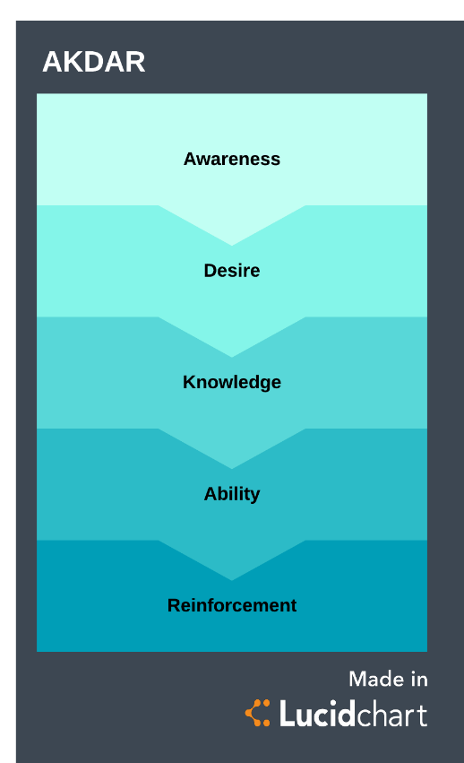
- Awareness: Awareness of the need to change
ADKAR Change Management Model
- Desire: Desire to participate in and support the change
- Knowledge: Knowledge of how to change
- Ability: Ability to implement the change
- Reinforcement: Reinforcement to sustain the change
Since organisational change is directly dependent upon its employees for successful implementation, it’s critical for individuals to have a clear understanding of what changes are occurring, why they are occurring, and how they affect them personally. The ADKAR model helps individuals process change through clearly defined stages that enable them to both understand and accept the changes at hand.
Kotter’s 8-step change model
Developed by John Kotter after a survey of over 100 organisations in flux, this 8-step change model also focuses more on the people experiencing large organisational changes rather than the changes themselves. The eight steps are:
- Create a sense of urgency.
- Build a strong coalition.
- Form a strategic vision.
- Get everyone’s buy-in.
- Enable action by removing barriers.
- Generate short-term wins.
- Sustain acceleration.
- Institute change.
Kotter’s change management process skilfully turns possibly resistant individuals into receptive participants through trust, transparency, and teamwork. By identifying the end goal, employing everyone’s involvement, and executing the impending changes together, this process remains a long-standing favourite among change management models.
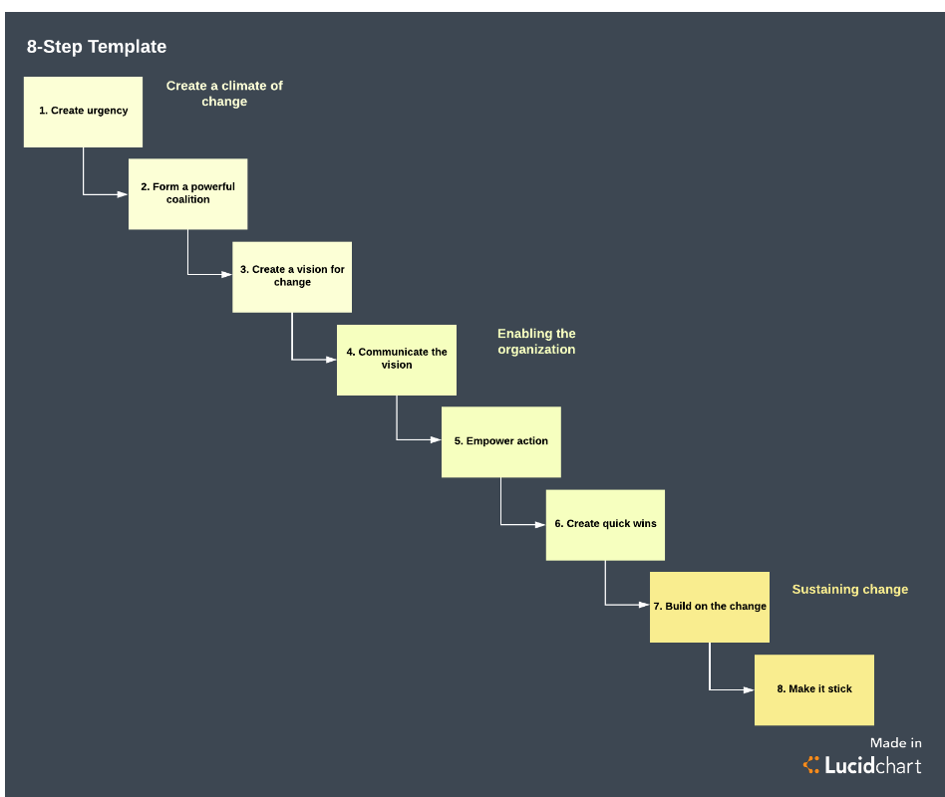
Kotter’s 8-step change model

Kubler-Ross change curve
Most widely known as the five stages of grief, the Kubler-Ross change curve can also be thought of as a reliable change management strategy due to its breakdown of how people process change in general. Organisations can better prepare for change when they also anticipate the possible reactions by their workforce. The five stages are:
- Denial
- Anger
- Bargaining
- Depression
- Acceptance
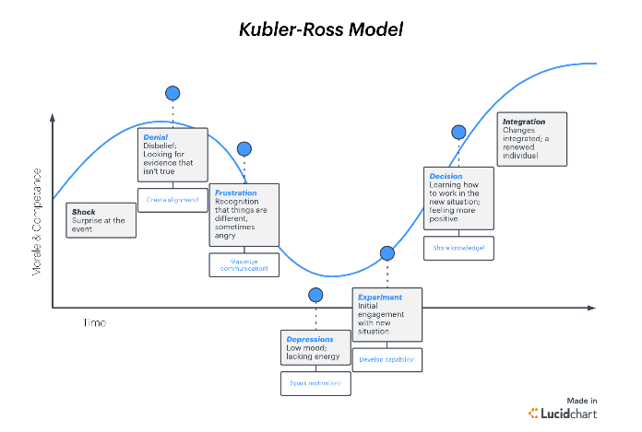
If teams and companies lose sight of whom their changes impact the most, then their attempts to make those changes will be for naught. Changing an organisation is not like changing a tire; there are emotional factors to consider. One caveat to consider with this change management strategy is that these stages are not always sequential and that everyone can progress through them differently, so its effectiveness is not always predictive. As such, it can also be used to supplement other change management process steps for a two-fold approach.

Critically assess the good and the bad points of each model and share this information with the class. And where possible, give an example from a business that has used these approaches to instigate change.

types of organisational change
Types of organisational change
Many internal and external factors can give rise to organisational change. For example, competition, new technologies, market instability, reorganisation, staff initiatives and many others.
Types of change
Depending on what causes it, business change can be reactive or planned. It can also be developmental, transitional, transformational or remedial.
Each type of change has a different degree of complexity and uncertainty and may require different implementation methods and commitment of resources.
Levels of change
There are three main levels where change can occur in a business:
- Individual – e.g. change in job assignment, transfer, change in job maturity level, etc
- Team or group – e.g. changes due to inefficiencies, lack of communication, etc
- Organisational – e.g. changes due to relocation, restructuring, mergers, acquisitions, etc
Each level has its own considerations, although change can affect one or more levels at the same time. It’s important to understand the impact of change across all levels, so that you can develop appropriate measures and interventions.
Categories of organisational change
Organisational change typically falls into four distinct categories:
- strategic
- structural
- technological or process-oriented
- people-oriented
Strategic organisational change is concerned with the overall goals and purpose of the business, and any changes in the vision and mission of the organisation. Process-oriented change focuses on new technologies, new skills and operating processes, while people-oriented change relates to employee performance, skills, attitudes, behaviours and relationships.
Change in organisational structure
Structural change in an organisation occurs when the business changes its:
- organisational hierarchy
- chain of command
- management systems
- job structure
- administrative procedures
A structural change may involve, for example:
- relocation or adaptation of business premises to accommodate extra staff
- relocation to a cheaper location or one nearer to customers, labour or transport links
- mergers and acquisitions to allow you to enter new markets, seize new opportunities or increase efficiencies
- flattening of your management structure
Risks associated with change
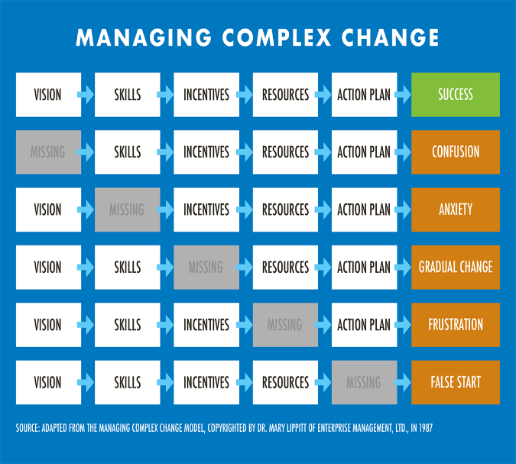
Any type of major organisational change can be stressful and risky. Potential challenges may arise in relation to staff retention, redundancies, relocation incentives, staff communication, merging of organisational cultures and processes, or altering your business structure.
Before you initiate change, make sure that the benefits justify the upheaval.
Source: NIBUSINESS

Who Moved My Cheese?
The story tells a parable, which you can directly apply to your own life, in order to stop fearing what lies ahead and instead thrive in an environment of change and uncertainty.
To better understand the story of “Who moved my cheese”, watch a video on Kotter’s 8-Step Change Model, so you can see how change can be mitigated.
Kotter's 8-Step Change Model – 2:20mins
https://youtu.be/xNILBjjVttA
Who Moved My Cheese? – 15.59 mins
https://youtu.be/doy2SK-QzXg


Think about some of the following reasons why people embrace or resist change.
Why people support change | Why people resist change
Source: Harvard Manage Mentor
5 Actions to Create Positive Change in the Workplace
Why do we go through Organisational Change? It’s usually to create more positive outcomes for the organisation. So why is it so difficult to create positive change in the workplace? And are there things managers can do to ensure successful change?
There’s no doubt that managing change is difficult, but it doesn’t have to be painful. In fact, with the right approach, you can create a more positive experience. Granted, the outcome may not make everyone happy. Sometimes change results in job losses and cutbacks. But you can minimise some of the impact through specific actions.
What specific actions can a leader take to create positive change in the workplace?
Change Leadership is much more than just putting on a smile and giving people pep talks. In fact, putting on this overly positive act could be offensive to those that are having difficulty with change. So, we need to start with values. For some leaders, these values are already just part of who they are. For others, these values must be developed over considerable time.
Start with a mindset of win-win
We often get caught up in all the negative aspects. And if that’s what you focus on, that’s all you see. So, if you open your mind to looking for win-win solutions, you may see opportunities to create the change you need while also looking after people. Right from the beginning, communicate that you will ensure the needs of others are considered and respected as you move towards your goal.
Be open and honest in communication
Communication is always important, but especially so during change. We sometimes think we are protecting people by not telling them things such as their jobs will change, or they may need to relocate, etc. But what we truly fear is coming off as “the bad guy.” Get over it! And you will need to incorporate a wide range of communication. Learn more in our article on tips for communicating during change.
Whenever possible, allow people to have input
One of the biggest challenges for people is feeling that they have no control over what happens to them. So, allowing people to have input helps them feel that they have some control, thus reducing their anxiety. And if you can’t allow input (after all, you do need to respect the direction of your own supervisor and executive, you can at least listen to their needs. Let them feel heard and understood. Employee engagement is a critical step in creating positive change.

Be open to alternative solutions
We can get so caught up in implementing change, that we fail to see new opportunities. Maybe we are striving to meet deadlines and focused on following the plan. But consider that others may be able to see a different way of achieving the goal. With alternative, we may be able to minimise harm and disruption to others. Don’t be so set on your process that you refuse to consider a different course.
Allow emotions
It can be difficult and uncomfortable to listen to others frustrations (or even your own!), but it is important to recognise that change can be an emotional time. Find ways for people to express themselves in a healthy and respectful manner. If we don’t allow the emotions, they can come out in other more damaging ways. Resentment may build, and people may react in ways that seem irrational.
Effective change requires a leader to demonstrate a positive attitude and constantly communicate positive expectations to employees and stakeholders. But perhaps most significantly, it requires commitment and courage to face the emotional ups and downs – including our own.
Build strong management skills in your organisation
Improve management skills on the job without large chunks of time and money.
Source: NMC Strategic Manager

What change have you gone through to get to where you are now. I.e. studying for a degree. Has it been easy? Tough? How did you compromise? If you had the gift of hindsight, what would you have done differently? What advice would you give a level four or five student, so that they can adapt to a new way of learning for the degree programme?

8 Ways Leaders Enable Innovation in Their Teams
Think innovation happens in a vacuum? Think again! The best ideas require out-of-the-box thinking, yes, but sometimes they also take inspiration — or maybe just an encouraging word at a critical moment. If you're a leader in the workplace or anywhere else, look at these eight suggestions for enabling higher levels of innovation from your team.
1. Set Time Aside for Innovation
Believe it or not, some of the biggest companies in the world make a point of building unstructured exploration and innovation time into their regular schedules. At Google, for example, this free time — called "20 percent time" because it's a full 20 percent of employees' time on campus — resulted in the creation of Google Earth and Gmail. The 3M company has had its own "15 percent time" for years as well. What's the most famous product to come out of this time? The all-powerful Post-It note.
2. Encourage and Increase Dialogue
We've all done time working for companies that don't value communication. And that's a shame, because some types of communication are positively essential when it comes to fostering innovation. The word "dialogue" sounds like just another synonym for "talking," but it's more than that. The root of the word comes from the Greek for "flow of meaning." Leaders are in a unique position to build an environment where employees can speak freely with one another and with leadership. The more ideas that get thrown around, the more likely you are to hit upon a winner.
3. Relinquish Some of Your "Ownership"
There can be a strong desire among leaders to feel a certain ownership over progress within the company. Some leaders even stifle dialogue and potential change in the name of the status quo. Among executives, 84 percent indicate innovation is critical for growth. And yet, just 6 percent say they're satisfied with the rate and quality of innovation. This disparity is, potentially, because they're too close to the issue and don't want things to stray too far from their vision, or they have too "fixed" an idea of what progress can look like.
4. Have a Vision for the Future
Most of the points we're talking about here focus on encouraging a more free-form, expressive and experimental workplace. But this isn't to say leaders should be flying entirely by the seat of their pants. Here's the question: What's innovation for? Mostly, it's about solving problems — even ones we didn't know about beforehand — and improving our circumstances. So what issues are you resolving with all this human capital? What's the point?
Leaders shouldn't be overly precious about their goals for their future of the company, but they should set some milestones. Providing a rough roadmap doesn't stifle creativity — but it can gently guide it toward a desired general outcome, even if the innovation part happens in the finer details.
5. Compromise on Scheduling
How many studies will researchers publish about the needs of the pre-adolescent brain before we shift our school start times to later in the day? Nobody does their best work when they're exhausted.
The same goes for the workplace: Employees who are overly anxious about their work-life balance, regularly exhausted due to long hours and overtime or struggling in another way, are probably not the ones who'll bring the next big idea to the table. To the extent that you can, make an effort to meet your team members halfway when it comes to scheduling. A satisfied, rested and refreshed employee is an employee who brings their A-game.
6. Put Trust Over Group think
Trust is one of the most important currencies in the modern workplace. But it's about more than feeling confident your team members will do the "right thing" in matters of ethics. Trust is also about leaders finding the confidence to let their people be themselves. There's a choice to make when an employee's thinking or practices start to diverge from business as usual. We can use force to course-correct, or we can trust their motivation comes from a wholesome place. When you let people be themselves at work, instead of enforcing groupthink, that's when the ideas truly begin to fly.
7. Become a Better Listener
As Mark Twain pointed out, humans have two ears and just one tongue, so we should do more listening than speaking. So why's this important? Because not every idea arrives fully formed. For example, there will probably be lots of times where, if you're actively listening to your team, you'll hear specific hints. Maybe it's dissatisfaction with company standards, or maybe there's another barrier to progress your employees are stumbling over, but don't quite know how to bring to your attention. Becoming a mindful listener means you'll be better able to pick up on innovative opportunities, or barriers to progress, that might've flown under your radar.
8. Pursue an Acquisition or Collaboration
Sometimes, the best shot in the arm for innovation comes from an infusion of new talent. Maybe it's a branding collaboration or even a full-blown acquisition. Co-branding between Nike and the Apple Watch yielded the Nike Run Club. And when Sherwin-Williams and Pottery Barn put their heads together, they came up with a whole new family of colours and a selection of original decorations and furnishings to accompany them. The point is, sometimes the intersection of two great ideas, or two great companies, can yield something unexpected and wonderful.
With these tools and ideas at your disposal, you might be ready to turn your workplace into an innovation powerhouse.
Source: Forbes, William Craig, Contributor

The article above talks a lot about driving innovation through teams.
You’ve applied for a new job that seeks to lead the Innovation team at Google Flights or Agoda. You have lots of great ideas and your brain is working overtime coming up with innovative ways to make Google Flights or Agoda’s hotel search website even more successful.
You’ve arrived at Google/Agoda HQ.
You did your research and you found out who the current Head of Innovation is at Google Flights/Agoda.
The trouble is you have just one-minute in the elevator, to pitch ways you can deliver your spiel to drive more innovation at Google Flights/Agoda. And get hired!
Your elevator pitch should induce your listener to invite you to “Tell me more” not shut you down with a “So what.”
Tips:
For example, if you’re a baker, rather than say “I make cakes for people,” say “I sweeten people’s lives.” If your company is designing jet-propelled rockets, rather than “We design rockets” say “We send people to the moon.” Use an opening phrase that surprises, or even shocks, the listener.
Make your elevator pitch about the listener and their problem (or the type and problem of client you seek). Every word you speak should be about what concerns the potential client — even though it’s about you.
The listener i.e. your trainer, should end your one-minute pitch with “When can I see you again as I’d love to hear and learn more….

All of you work for a tourism organisation that employs workers who belong to a trade union. The head of the trade union and the Managing Director (MD) appear to not see eye-to-eye with the far-reaching changes that have been proposed by MD and the senior leadership team. A confidential memo has been issued stating that urgent change is required, or the business could go into administration. The head of the trade union and their team feel that change is unnecessary, as they believe the forthcoming re-structure and other changes are over the top. Whereas, the MD and the leadership team feel that if the company is to survive in the short and medium term, urgent change is required across the whole business.
Conduct a debate. One side represents the trade union and wishes to resist the changes and the other side represents the wishes and demands of the Managing Director and the senior leadership team.

Your trainer will send you a document by Kotter and Schlesinger entitled “Choosing Strategies for change”.
Conduct a classroom discussion regarding the ideas presented, and state what you would consider to be the most important strategy to deal with resistance, and why?


Below are a variety of fun and engaging change management activities by Change for you to try:
- Cross Your Arms

How to participate:
Your trainer will ask you (as ‘employees’) to cross your arms. When you are comfortable, your trainer will ask you to cross your arms the other way. Once you’ve done this, your trainer will ask you why the second attempt might have left you feeling uncomfortable, even though it’s basically the same action.
- The Alien at Dinner

How to participate:
Your trainer will ask you (as ‘employees’) to imagine yourselves as aliens observing a human dinner party. Your task is to point out unusual human social norms and to explain them to the beings on their imaginary planet. Why do they drink poisonous alcohol? Why do they knock their glasses together when celebrating?
- Changing Places

How to participate:
Your trainer will allow you to sit wherever you want… then you will be asked to move to a different seat. Your trainer will ask you to think about how your perspective changed in moving to the new seat and why. After stretching for a minute, your trainer will ask you again to sit wherever you want.
- Bouncing Back

How to participate:
In a spacious area, hand out bouncy balls for pairs of students to bounce back and forth for a few minutes. Then, ask students if they ever had any doubts that the ball would fail to bounce back up?

- The Can-Do Company

How to participate:
For this final change management exercise, divide students into groups and have them come up with an idea for a company such as an airport transfer service for VIPs, a lockable travel bag for a beachgoer, a smart suitcase for a business traveller and an ultimate pack of sprayable liquid vitamins to carry in hand luggage.
Your trainer will assign members of each group to specific job functions like designing, marketing, distributing, etc. Have each “mini-company” collaborate and prepare a presentation on your product and/or service.
Source: Change
THE ENHANCED CHANGE MANAGEMENT TOOLKIT
BCG’s enhanced change management approach provides a suite of tools and solutions that overlays and augments the core change management portfolio. It has four components.

Catalytic Leadership, to help leaders spearhead the change. To advance the change effort, top leaders must mobilise the broader leadership team and the organisation overall. The Leadership Activation program combines elements aimed at individual and collective leadership-building to ensure that leaders are united, committed, energised, and equipped. A change maturity heat map helps assess leaders’ level of change-readiness. A leadership profiling tool reinforces individual leadership development. These combined with change booster collective sessions, help foster alignment among leaders on their vision and priorities—and fortify leadership team effectiveness.

Activist Programme Management, to speed change. Transformation today calls for a fundamentally new approach to program management that supports speed, iteration, and adaptiveness. The evidence shows that agile organisations are dramatically more successful than traditional organisations in many aspects of managing change. The Project Management Institute’s 2015 Pulse of the Profession study revealed that agile organisations are six times more effective at anticipating external change, eight times more effective at developing strategies to respond, and 10 times more effective at implementing those strategies.

At BCG, we believe in Activist Programme Management, a form of programme management that is, above all, strong, direct, and proactive. Key, our proprietary approach, fortifies governance and program management through agile methods and practices. It includes a software platform with analytic capabilities that allows rigorous end-to-end management of the change portfolio and programs. Key helps leaders reach agreement on initiative targets and efficiently track milestones. The transparency and discipline it builds into the program helps accelerate progress. Impact centres—physical rooms and routines, such as a virtual control tower, portfolio walls, and stand-up meetings—provide transparency and enable rapid decision making. Together, these solutions give leaders an adaptable way to address evolving demands, solve problems, and manage and prioritise the change portfolio with transparency and speed.

Open Source Engagement, to foster employee co-creation. As we’ve shown, the case for inclusiveness in change efforts is compelling, and digital technologies support inclusiveness to a degree previously unimaginable. When used correctly, digital tools enable employees and leaders to work together to co-create change efforts. Tuned, BCG’s employee engagement app, uses mobile technology to promote employee interaction—peer to peer, up and down, and across the organisation—in a way that is simple enough for the technology-challenged executive or shop-floor employee to grasp easily. It can issue simple notifications to the whole company or to specific segments of the workforce, enable pulse-checks, and provide gamification elements (such as leader boards) and feedback view mechanisms (such as real-time polls). Tuned relies on bite-sized content—90-second videos, short texts—that are digestible and easy to respond to. It thus serves as a mechanism for engaging employees and stimulating dialogue, ultimately boosting employees’ empowerment and investment in the change.

Enablement, to ingrain new behaviours. If behaviour change is the key to successful change, companies need to define and foster desired behaviours: hardwiring new routines into systems and structures, and ensuring knowledge transfer, up-skilling, and training for the new technologies and processes. Amethyst, a learning and behaviour-change app, supports training and coaching for leaders or managers (although it can be used for any audience). It incorporates digital nudges, a concept drawn from behavioural economics; text messages, emails, apps, and gamification to prompt people to take desired actions. Because they generate data, digital nudges have the added benefit of enabling organisations to track the effectiveness of their change efforts. (See “The Persuasive Power of the Digital Nudge,” May 2017.)

The traditional foundational approach to change management, no matter how rigorous, is no longer sufficient. Yet digital tools alone cannot possibly enable an organisation to achieve large-scale, sustainable change. When combined, however, the two create a powerful and holistic way for change leaders to articulate, plan, deploy, and measure the results of their most significant change efforts. And by addressing the four new imperatives for change, companies can confidently meet the demands of always-on transformation as they navigate the broader forces of technological, operational, and cultural change with competitive might.

business profile: culture / values & communication
Understanding and Developing Organisational Culture
Overview

The key to a successful organisation is to have a culture based on a strongly held and widely shared set of beliefs that are supported by strategy and structure. When an organisation has a strong culture, three things happen: Employees know how top management wants them to respond to any situation, employees believe that the expected response is the proper one, and employees know that they will be rewarded for demonstrating the organisation's values.

HR has a vital role in perpetuating a strong culture, starting with recruiting and selecting applicants who will share the organisation's beliefs and thrive in that culture. HR also develops orientation, training and performance management programs that outline and reinforce the organisation's core values and ensures that appropriate rewards and recognition go to employees who truly embody the values.

This article covers the following topics:

- The importance of having a strong organisational culture
- Definitions of organisational culture
- Factors that shape an organisation's culture
- Considerations in creating and managing organisational culture
- Communications, metrics, legal, technology and global issues pertaining to organisational culture

Background

An organisation's culture defines the proper way to behave within the organisation. This culture consists of shared beliefs and values established by leaders and then communicated and reinforced through various methods, ultimately shaping employee perceptions, behaviours and understanding. Organisational culture sets the context for everything an enterprise does. Because industries and situations vary significantly, there is not a one-size-fits-all culture template that meets the needs of all organisations.
A strong culture is a common denominator among the most successful companies. All have consensus at the top regarding cultural priorities, and those values focus not on individuals but on the organisation and its goals. Leaders in successful companies live their cultures every day and go out of their way to communicate their cultural identities to employees as well as prospective new hires. They are clear about their values and how those values define their organisations and determine how the organisations run.
Source: SHRM

What does it mean to be a ‘values-based’ organisation?

Mergers and acquisitions are fraught with culture issues. Even organisational cultures that have worked well may develop into a dysfunctional culture after a merger. Research has shown that two out of three mergers fail because of cultural problems. Blending and redefining the cultures, and reconciling the differences between them, build a common platform for the future. In recent years, the fast pace of mergers and acquisitions has changed the way businesses now meld. The focus in mergers has shifted away from blending cultures and has moved toward meeting specific business objectives. Some experts believe that if the right business plan and agenda are in place during a merger, a strong corporate culture will develop naturally.
Business Case
If an organisation's culture is going to improve the organisation's overall performance, the culture must provide a strategic competitive advantage, and beliefs and values must be widely shared and firmly upheld. A strong culture can bring benefits such as enhanced trust and cooperation, fewer disagreements and more-efficient decision-making. Culture also provides an informal control mechanism, a strong sense of identification with the organisation and shared understanding among employees about what is important. Employees whose organisations have strongly defined cultures can also justify their behaviours at work because those behaviours fit the culture.
Company leaders play an instrumental role in shaping and sustaining organisational culture. If the executives themselves do not fit into an organisation's culture, they often fail in their jobs or quit due to poor fit. Consequently, when organisations hire C-suite executives, these individuals should have both the requisite skills and the ability to fit into the company culture.
What Is Organisational Culture?
For HR professionals to have any impact on culture, they must first have a thorough understanding of what culture is in a general sense and what their organisation's specific culture is. At the deepest level, an organisation's culture is based on values derived from basic assumptions about the following:
Human nature. Are people inherently good or bad, mutable or immutable, proactive or reactive? These basic assumptions lead to beliefs about how employees, customers and suppliers should interact and how they should be managed.
The organisation's relationship to its environment. How does the organisation define its business and its constituencies?
Appropriate emotions. Which emotions should people be encouraged to express, and which ones should be suppressed?
Effectiveness. What metrics show whether the organisation and its individual components are doing well? An organisation will be effective only when the culture is supported by an appropriate business strategy and a structure that is appropriate for both the business and the desired culture.
Culture is a nebulous concept and is often an undefined aspect of an organisation. Although extensive academic literature exists relating to the topic of organisational culture, there is no generally accepted definition of culture. Instead, the literature expresses many different views as to what organisational culture is.
Organisational culture can manifest itself in a variety of ways, including leadership behaviours, communication styles, internally distributed messages and corporate celebrations. Given that culture comprises so many elements, it is not surprising that terms for describing specific cultures vary widely. Some commonly used terms for describing cultures include aggressive, customer-focused, innovative, fun, ethical, research-driven, technology-driven, process-oriented, hierarchical, family-friendly and risk-taking.

Because culture is difficult to define, organisations may have trouble maintaining consistency in their messages about culture. Employees may also find it difficult to identify and communicate about perceived cultural inconsistencies.
Factors That Shape an Organisation's Culture
Organisational leaders often speak about the unusual natures of their company cultures, seeing their domains as special places to work. But organisations such as Disney and Nordstrom, which are well-known for their unique cultures, are rare.
Most company cultures are not that different from one another. Even organisations in disparate industries such as manufacturing and health care tend to share a common core of cultural values. For example, most private-sector companies want to grow and increase revenues. Most strive to be team-oriented and to demonstrate concern for others. Most are driven, rather than relaxed, because they are competing for dollars and market share. Some of the cultural characteristics that distinguish most organisations include the following.
Values
At the heart of organisations' cultures are commonly shared values. None is right or wrong, but organisations need to decide which values they will emphasise. These common values include:
- Outcome orientation. Emphasising achievements and results.
- People orientation. Insisting on fairness, tolerance and respect for the individual.
- Team orientation. Emphasising and rewarding collaboration.
- Attention to detail. Valuing precision and approaching situations and problems analytically.
- Stability. Providing security and following a predictable course.
- Innovation. Encouraging experimentation and risk-taking.
- Aggressiveness. Stimulating a fiercely competitive spirit.
Degree of hierarchy
The degree of hierarchy is the extent to which the organisation values traditional channels of authority. The three distinct levels of hierarchy are "high"—having a well-defined organisational structure and an expectation that people will work through official channels; "moderate"—having a defined structure but an acceptance that people often work outside formal channels; and "low" —having loosely defined job descriptions and accepting that people challenge authority.
An organisation with a high level of hierarchy tends to be more formal and moves more slowly than an organisation with a low level of hierarchy.
Degree of urgency
The degree of urgency defines how quickly the organisation wants or needs to drive decision-making and innovation. Some organisations choose their degree of urgency, but others have it thrust on them by the marketplace.
A culture with high levels of urgency has a need to push projects through quickly and a high need to respond to a changing marketplace. A moderate level of urgency moves projects at a reasonable pace. A low level of urgency means people work slowly and consistently, valuing quality over efficiency. An organisation with high urgency tends to be fast-paced and supports a decisive management style. An organisation with low urgency tends to be more methodical and supports a more considered management style.
People orientation or task orientation
Organisations usually have a dominant way of valuing people and tasks. An organisation with a strong people orientation tends to put people first when making decisions and believes that people drive the organisation's performance and productivity. An organisation with a strong task orientation tends to put tasks and processes first when making decisions and believes that efficiency and quality drive organisation performance and productivity.
Some organisations may get to choose their people and task orientations. But others may have to fit their orientation to the nature of their industry, historical issues or operational processes.
Functional orientation
Every organisation puts an emphasis on certain functional areas. Examples of functional orientations may include marketing, operations, research and development, engineering or service. For example, an innovative organisation known for its research and development may have at its core a functional orientation toward R&D. A hospitality company may focus on operations or service, depending on its historical choices and its definition in the marketplace.
Employees from different functions in the company may think that their functional areas are the ones that drive the organisation. Organisational leaders must understand what most employees perceive to be the company's functional orientation.
Organisational subcultures
Any organisation can have a mix of subcultures in addition to the dominant culture. Subcultures exist among groups or individuals who may have their own rituals and traditions that, although not shared by the rest of the organisation, can deepen and underscore the organisation's core values. Subcultures can also cause serious problems.
For example, regional cultures often differ from the overall culture that top leadership tries to instill. Perhaps aggressiveness that is common in one area may not mesh with a culture emphasising team building. Or an organisation with a culture built around equality may have trouble if the national culture emphasises hierarchy and expects people to bow to authority. Managers and HR professionals must recognise those differences and address them directly.
Creating and Managing Organisational Culture
An organisational culture tends to emerge over time, shaped by the organisation's leadership and by actions and values perceived to have contributed to earlier successes. A company culture can be managed through the cultural awareness of organisational leaders and HR professionals. Managing a culture takes focused efforts to sustain elements of the culture that support organisational effectiveness.
How culture develops
An organisation's customs, traditions, rituals, behavioural norms, symbols and general way of doing things are the visible manifestation of its culture; they are what one sees when walking into the organisation. The current organisational culture is usually due to factors that have worked well for the organisation in the past.
Founders typically have a significant impact on an organisation's early culture. Over time, behavioural norms develop that are consistent with the organisation's values. For example, in some organisations, resolution of conflicts is hashed out openly and noisily to create widespread consensus, whereas in other places disputes are settled hierarchically and quietly behind closed doors.
Though culture emerges naturally in most organisations, strong cultures often begin with a process called "values blueprinting," which involves a candid conversation with leaders from across the organisation. Once the culture is framed, an organisation may establish a values committee that has a direct link to leadership. This group makes sure the desired culture is alive and well. For values blueprinting to work, organisations must first hire people who live the values and have the competency needed to perform the job.
Sustaining a culture
The management of organisational culture starts with identifying a company's organisational culture traits or "artefacts." Artefacts are the core business activities, processes and philosophies that characterise how an organisation does business day-to-day.
Identifying these traits—and assessing their importance in light of current business objectives—is a way to start managing culture. Three broad concepts help identify the traits specific to a culture:
Social culture. This refers to group members' roles and responsibilities. It is the study of class distinctions and the distribution of power that exists in any group.
Material culture. This involves examining everything that people in a group make or achieve and the ways people work with and support one another in exchanging required goods and services.
Ideological culture. This is tied to a group's values, beliefs and ideals—the things people view as fundamental. It includes the emotional and intellectual guidelines that govern people's daily existence and interactions.
Leaders and HR professionals within an organisation should approach culture management by initially gaining an understanding of the common traits found in all businesses. Then, they should take the following steps to manage their organisation's culture:
Identify common artefacts or traits, including those from the standpoint of an organisation's social, material and ideological culture.
Convene groups of employees—representatives from all levels, functions and locations of the organisation—to assess the validity, significance and currency of key artefacts.
Subject those traits to a rigorous assessment of their underlying shared assumptions, values and beliefs.
Summarise findings and share them with all participants to solicit additional insights.
Create a culture management action plan. The plan should enhance traits that support corporate growth or organisational effectiveness and correct traits that might hinder a company's advancement.
Typically, shared assumptions and beliefs originate with an organisation's founders and leaders. Because those beliefs proved successful (otherwise the company would not exist and the leaders would not be in their positions), often they go unchallenged; however, those assumptions and beliefs might be outdated and may hinder future success.

Communications
Conflicting messages regarding corporate culture may create distrust and cynicism, which can prompt, or help employees justify, actions as deleterious as embezzlement. Experts say that cultural inconsistencies may also cause workers to grow discouraged, to believe management is disingenuous, to doubt statements from higher-ups and to be less inclined to give their best effort.
Organisations may be investing significant time and money in creating a culture but may not be reaping the commensurate rewards—especially if executives, supervisors and rank-and-file employees have differing perceptions of the company's culture. HR professionals must therefore ensure that the organisation clearly and consistently communicates its culture to all employees.
Metrics
Assessing organisational culture is a crucial step in developing sound HR strategies that support enterprise objectives and goals. But how do you measure something as potentially tough to describe as culture? After identifying the key dimensions of culture such as values, degree of hierarchy, and people and task orientations, performing these next steps will help organisations assess culture:
- Develop a cultural assessment instrument. This instrument should enable members of the organisation to rate the organisation on the key cultural dimensions, as well as on aspects of the organisation not covered on the assessment
- Administer the assessment. Survey respondents should include individuals at all levels, functions, divisions and geographical units of the organisation
- Analyse and communicate about assessment results. Leaders and HR executives should discuss areas of agreement and disagreement about the organisation's culture
- Conduct employee focus groups. Just because top management leaders agree on organisational culture does not mean that all employees see things that way
- Discuss culture until consensus forms around key issues. Focus on "Who are we?" and "What makes us who we are?" Organisations that decide that where they are now is not where they want to be may need to look at moving the organisation to embrace a different culture
Cultural assessments, and other activities such as cultural audits and 360-degree feedback, may also help uncover cultural inconsistencies. Then leaders and HR professionals can eliminate the inconsistencies. For example, if customer service is a focus of the company's culture, evaluate how much time employees spend visiting customer sites, how much interaction they have with customers, what customer service training they receive and other indicators of a customer service focus.
Legal Issues
Employers that emphasise cultural fit in their recruitment and selection process can be vulnerable to discrimination claims if they are not careful. HR professionals should ensure that hiring practices and selection decisions based on a cultural fit rationale do not result in discriminating against any applicants who may not be "just like" the selectors.
Employers should also be aware that certain types of organisational cultures (for example, cultures that are highly paternalistic or male-dominated) may tend to perpetuate disparities in promotions, compensation and other terms of employment. Those disparities may violate anti-discrimination laws.
Global Issues
Research suggests that national culture has a greater effect on employees than the culture of their organisation. Organisational leaders and HR professionals should understand the national cultural values in the countries in which the organisation operates to ensure that management and HR practices are appropriate and will be effective in operations in those countries. National cultural differences should be considered when implementing organisational culture management initiatives in global businesses.
Managers must be able to respond to nuances in communication styles, as well as deal with different expectations that employees have of their leaders across national cultures. Not meeting those expectations may doom the global organisation's chance for success in particular countries.

These issues become even more complex in global business mergers. Success in international mergers depends on the merged organisation's willingness to enable people with different cultural perspectives to engage in meaningful and valuable discussions about the new business.
Culture, Leadership, Performance: How Are They Linked?

Every organisation has its own culture. And I’m not referring to the kind you find in a cup of yogurt.
Rather than recite an esoteric definition, which would sound like gobbledygook anyway, let’s consider the ingredients of culture in layman’s terms.
The culture of any social unit includes group norms, shared perceptions, espoused values, and consensus around goals and objectives.
Culture includes the way people interact with each other, how they solve problems, and how they justify themselves.
Culture includes artefacts like furniture (metal desks versus mahogany) and physical layout (bullpen versus corner office with a view).
In summary, culture could be described as “the way we get stuff done around here.”
I’ve worked with a lot of organisations that seem to regard culture as important. In one place I might ask “Why do you do things the way you do them here?” People will recite their espoused values and say something like “We’re very informal here because we believe in teamwork and open communication.” Then I go to another place—in the very same industry supposedly operating by the same regulations—and someone will tell me “We’re very tightly structured, here. We play strictly by the rules. We don’t talk much. We just do as we’re told.”
Different strokes for different folks.
Of course, having “rules” doesn’t necessarily mean that people follow them. I’ve seen sincere and earnest people pull little cards out of their pockets and read off the values they profess to embrace. But then I’ve noticed that their behaviours and artefacts don’t square with the professed values.
Source: Forbes
5 Things All Great Leaders Do to Create a Culture of Leadership
What’s the secret to creating a culture of leadership that will take your organisation forward for years to come? There is no secret — it starts at the top with you.
In my experience as a leadership speaker and consultant, it starts with senior leaders reflecting internally — to understand their purpose, gain clarity about what they stand for and what the organisation stands for — and identifying how to communicate this with the rest of your organisation.
It is the strength of individuals who make an organisation world class. And companies that make leadership development a strategic priority has the ability to attract and retain the best leadership talent and move to the head of the pack.
Leadership Culture Starts at the Top
Transformational leaders understand that a culture of leadership doesn’t start with a written document, but by the behaviours they model every day. You can’t simply write down what you want your leadership culture to be and expect others to follow. Your culture is made up of the values you live daily — and those are not aspirational — they are actual.
Leaders must understand and communicate a clear vision to create an environment that attracts people who share their same values.
“Leaders understand culture doesn’t start with a written document, but by behaviours they model.”
You lay the groundwork by being clear with your purpose, and by leading by example and modelling the behaviours they would like to see practiced. Only then can you begin to establish the right structures and processes to foster and reinforce the desired culture.
If you want to develop great leaders, you first need to learn to be a great leader yourself.
5 Things All Great Leaders Do to Create a Culture of Leadership
While it’s easy to assume that great leaders were born to lead — and some are — more often great leadership is a result hard work, gaining experience over time, continuously evolving, and being open to learning new skills and trying different approaches. Thankfully, most of us were not born a natural leader, we had to learn — and this willingness to grow and develop will help create a culture of leadership.
Here are 5 things that great leaders do to help create a culture of leadership:
- Define clarity of purpose: All great leaders find their purpose. It’s clearly defined, and it is the catalyst for everything they do. Purpose helps to fuel their work ethic and drive their passion for what they do. More importantly, they create a purpose that resonates with others, and they communicate organisational values and vision in a way that brings people together to rally behind their vision, creating a strong culture of leadership.

- Walk the talk: You must reinforce company culture and values daily and with consistency. Leadership culture is a living and breathing entity. Strong leaders understand that organisational culture is dynamic and know it’s critical to reflect a culture of leadership through their actions. If your team sees you practicing what you preach, they will be more open to buy-in. Values should be a regular touch point in decision-making to ensure they are being lived every day — not just when it is easy or convenient. Leaders also establish a culture of leadership when they hire new people by hiring for character over competence (Read Three Critical Elements for Finding the Right People to Work in High Performance Environments) and establishing expectations clearly during onboarding, training, and coaching, and by putting people in leadership positions who share the same values and live them consistently. Read more: Why Leaders Need to Reinforce Company Culture and Values.

- Practice self-awareness: Leaders need to be willing to change first — before organisations can change and transform. Leaders need to have the ability to be self-aware, as well as organisationally and culturally aware, of the impact of their actions and decisions. They allow others to have a voice, they are open to critique and outside ideas, and they are willing to grow individually and professionally. Read more: Leaders Need to Change First Before Organisations Change.

- Recognise the value of people: Great leaders understand that the most valuable resource in their organisation is people. They invest in people and help them develop their own leadership capacity — scaling it throughout the organisation. Transformational leaders have a genuine desire to lift people up to achieve their own success.

- Create transformative organisational change: Leaders themselves need to be transformative in order to inspire higher performance and a customer-focused culture. In 6 Ways for Leaders to Create Organisational Change, “how you approach change is just as important as what you want to change. If you want to be a transformative leader and create long-lasting organisational change, you need to approach it in a way which minimises negative reactions, is aligned with business strategies and corporate cultures and is inclusive in nature.”
Anyone can be in a leadership position, but this doesn’t mean they are a leader. There is a difference between managing and leading. Managers look after things/checklists (budgets, invoices, scheduling, reports) and usually do so from behind a desk.
However, people are led. Great leaders know that to connect with their teams, they need to be engaged — ready to step in and support their people, even working side by side to get the job done. Leaders take the time to build their social skills and interact with others so that there is a strong teamwork atmosphere.
Forget about looking for the secret formula or shortcuts to create a culture of leadership. You won’t find them. Start by taking a look in the mirror and reflecting on your own leadership. This is the first place to look for answers about how to create a culture of leadership.
Source: Bill Hogg & Associates

Discuss the following statement “Anyone can be in a leadership position, but this doesn’t mean they are a leader.” Do you agree? What does it mean?
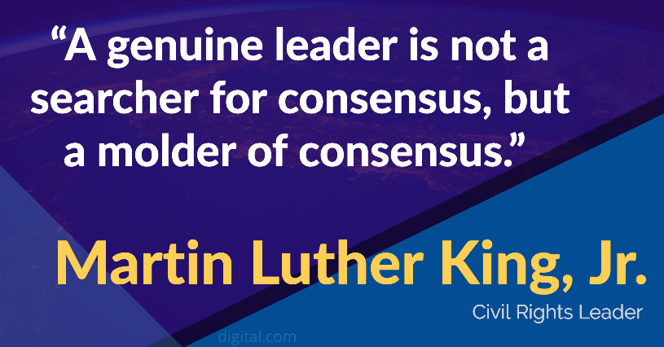


Image source: Digital.com
Leadership Communication
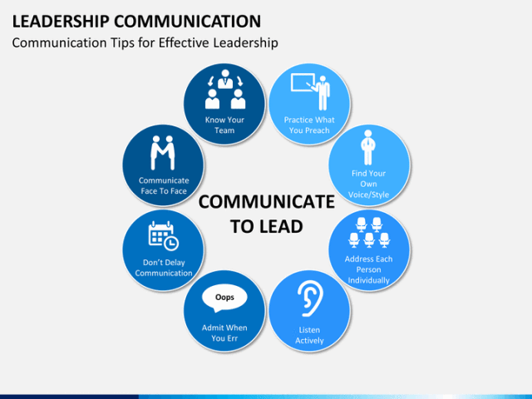
Image source: Susie Brilley
As leaders, communication is a central skill for accomplishing the goals and outcomes our organisations desire. We are tempted to view communication in very monolithic ways such as COMMUNICATION = TALKING. However, in the flow of leadership, communication is more nuanced than this. Yes, it includes talking, but there are other types and levels at which communication does and must take place.

Here are 5 categories or types of leadership communication.

- Verbal & Nonverbal
The first type of communication is verbal and nonverbal. Whether you want to or not, as a leader you are always communicating. This may be happening with your words, or it may be happening with your nonverbal cues. How many times have you been in a meeting with someone who is constantly looking at their watch or looking out the window rather than paying attention to the conversation in which they are engaged? Such nonverbal cues communicate powerfully. They powerfully communicate disinterest and lack of engagement.

As leaders, both our verbal and nonverbal communication matter immensely. What are you communicating with your words? What are you communicating with your nonverbal cues? Is there continuity or discontinuity in these threads of communication?

- Intentional & Unintentional

Communication may be verbal or nonverbal. It also may be intended or unintended on the part of the leader. This is the second type—intentional and unintentional communication. Saying the thing we wish to say, in the way we wish to say it, at the time we wish to say it is one example of intentional communication. But it does not always work this way in leadership. Sometimes we unintentionally say the wrong thing, in the wrong manner, or at the wrong time. Other times we may unintentionally communicate conflicting messages—saying one with our words intentionally and another message with our actions non-verbally.

Our intentional and unintentional communication are both important. What are you communicating intentionally? Are you aware of what is communicated unintentionally?

- Conscious & Unconscious

The third type of communication is conscious and unconscious. This third type of communication builds on the above foci. Verbal, nonverbal, intentional, and unintentional communication can take place either consciously or unconsciously. I may be communicating something both nonverbally and unintentionally, but still be aware of it. The real challenge to leaders is that which is communicated unconsciously. This takes intentional effort to address. Such effort may take the form of inviting others to observe us and give us feedback. Unconscious communication may support our leadership goals, or they may be working against us. Others can help us pay attention to our approach to communication.

The discussion of conscious and unconscious communication relates to a concept known as the Johari Window. The blind spot and unknown quadrants in the table below represent unconscious areas. When we are communicating at these levels, especially when we communicate negatively, it is important to invite the feedback of others so that we may raise these areas to the conscious level and proactively improve the leadership message communicated.

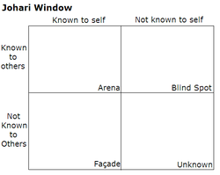
Source: Johari Window image, from Wikipedia
How to use the Johari Window – 4.33 mins
https://youtu.be/tbd83s0arbs

- Action & Inaction

The fourth type of communication is action and inaction. As with the above types of communication, effective leadership communication practice must pay attention to both action and inaction. Kouzes and Posner emphasise the priority of modelling the way in their book The Leadership Challenge. Modelling the way is an example of positive action communicating a desired leadership message. However, inaction also communicates powerfully. For example, if a leader consistently avoids confronting unhelpful or unethical behaviour on a team, this inaction communicates a powerful and negative message to other team members seeking healthy and ethical team performance.

How are you communicating as a leader through your actions? What leadership messages are communicated through your inaction? What needs to change in light of these observations?

- Head & Heart

The final type I’ll note is head and heart communication—communication at both the cognitive and affective levels. This distinction acknowledges that leaders communicate both cognitively and affectively. They communicate at both the level of the head and the heart. Challenges arise when leaders are communicating at one level while followers need another. In some ways, this distinction relates to the dimensions of intellectual stimulation and inspirational motivation within transformational leadership theory. At times, followers may be need affective, heart-oriented, and inspirational motivation from their leader. Challenges arise when leaders communicate in just the opposite manner—communication at the cognitive, head-oriented, and intellectual level. Leaders must look not only to what needs to be said and how they as leaders need to say it. Leaders must also look to how followers and organisational members need to hear a message.

Overview questions to think about
Do you tend to communicate more cognitively or affectively?
Are you emphasising your personal communication style preference in this area as a leader, or are you providing your community and followers with the type and style of communication that they need?

Source: PurposeinLeadership
How to write a company profile
Writing a company profile can at times appear to be a little bit intimidating. A company profile’s purpose, after all, is not just to include basic details, but to clearly and confidently highlight the strengths of your company. You can think of it as your company’s resume.
What Is a Company Profile?
A company profile is a professional summary of the business and its activities. You need a company profile if you want to raise capital and win investors, but you can also use it to inform other stakeholders, including clients.
You will find many variations and lengths for a company profile. Some businesses may not have grown enough yet and have profiles that are just two pages long. On the other hand, some might include awards, certifications, and a large client portfolio, topping out at 30 pages.
The bottom line with both situations, as well as those in between, is that a company profile is your business’s time to shine.
Do your best to comprise a well-written document so that it is clear, concise, and correct. Check your spelling and grammar, look for typos, and be sure to read it several times.

What to Include in Your Company Profile?
The Business Details
When you begin, gather the details listed below. These items should appear at the beginning of your company profile. Keep them accurate and up-to-date.
- Company name
- Established date
- Physical address per location
- Phone and fax numbers
- Website URL
- Email address
The Company Basics
These items will vary depending on your business type. So, just keep in mind that they may not all apply to your company, but you should include those that do.
- Description of the business including the mission and/or vision
- Product descriptions
- Description of services
- History, expansion, and growth
- Public relations
- Advertising
- Industry information
- Safety, health, and environmental policies
- Core team details
- Client portfolio
The Highlights
The next set of items also will not apply to every company. These are some of the types of notable achievements and accomplishments that you should include.
- Awards
- Certifications
- Special programs and projects
- Testimonials
- News or media recognition
Optional Items
You may see the following items in other company profiles or within the samples and templates below. If you feel that any of these is noteworthy for your business, then you should include them.
- Annual sales
- Financial targets
- Number of employees
- Partners
- Photographs
Source: MakeUseOf (MUO)
If you visit www.handypdf.com, you should be able to search Fillable Printable Business Profile Sample, or Fillable Printable Business Profile Example to edit and download the form. In order to edit the form, you must have the right software installed to edit a PDF. Alternatively, you can always try to convert a PDF into Word by using some of the free software online.
In addition, your trainer can send you two documents that have been saved in the Resources folder entitled:
Tourism New Zealand: Four-Year Strategic Plan – Focus on page 9 in the Word doc, as it’s a great example of using an infographic to highlight important information.

Source: Tourism New Zealand

The other document is entitled: Company Profile Template – IMPACT. You should be able to edit this document.
Using the example from Tourism New Zealand, design a business profile as an infographic. Make sure you outline the culture, values, management style and communication that promotes a positive response to change.
8 Proven Methods for Responding to Employee Feedback
At this point, it’s no secret that employee feedback provides company leaders with incomparable visibility inside the worlds of their employees. Asking your team for honest feedback surfaces challenges, concerns, triumphs and ideas for improvement from the people who know your business best. But simply asking questions at regular intervals is not enough.

Without a strategy in place, collecting feedback can do more harm than good (for example, receiving feedback without offering an acknowledgement opens up a whole other can o’ worms). But as part of an overall employee communication plan, nothing is more valuable for increasing engagement, retention, and success.

Building Trust

As Chief Culture Officer at 15Five, I have learned that giving feedback means investing in relationships and taking an active stand for your team’s development and satisfaction. You are inviting people – who you may not know that well – to communicate (often vulnerably) about all aspects of their jobs and even their personal lives. This can feel rather daunting for employees, who can perceive a higher emotional risk if things don’t ‘go right’.

The foundation of this feedback is trust. In the professional sense, this is the understanding that transparency will benefit rather than undermine the working relationship. Rather than just expecting employees to come to you truthfully at the onset, consider ‘What must I do to gain trust’?

I recommend having an opening conversation about how you as a manager are truly invested in learning about their experience and making it better. This might seem obvious to you but communicating this explicitly lets employees know your intentions for collecting candid information.

Forging Relationships

Once you explain your motivations in a way that make employees feel safe, supplement your first several 15Five’s with questions that are fun and engaging, and to which there’s less likely to be negative judgement around the answers.

For example, you can ask “What would you like to be doing in 6 months that you aren’t currently doing?” This question is clearly geared towards an employee’s personal and professional development. You aren’t just telling them that you’re invested in their wellness, you’re showing them. This goes a long way towards building trust.

Then you can use the application as a virtual starting point that integrates into non-virtual communication methods or routines. The most successful clients gather insights, and then find ways to deepen the conversation in 1-to-1 meetings, department gatherings, even company events that centre around the collective contribution.

Question everything

Despite the wide range of goals and cultural values that different companies establish, all leaders can benefit from a framework of solid communication practices. We distilled the following 8 “buckets” that will offer incredibly fruitful insight for any organisation:

1) Asking employees to share their triumphs is a great morale booster.

2) Uncover employee challenges so that you can offer support.

3) Find out what’s going on in their personal lives that might be affecting work performance.

4) Uncover issues before they become full-blown problems.

5) Ask for ideas and suggestions to improve the company or its products/services.

6) Inquire about the office environment or the team. Check in on the morale and cultural health.

7) Solicit opinions about your leadership.

8) Ask if people understand their priorities to always maintain alignment with company goals.

Receiving feedback in these areas has tremendous value, and there are simple and effective ways to respond that create an authentic and positive experience for employees:

“It’s not just about the questions you ask employees, it’s how you respond to their answers.”

1) A little feedback goes a long way. Don’t feel compelled to respond to every answer. Simply ‘liking’ a couple of answers and marking the report as reviewed lets employees know that you actually saw it, instead of it thinking it is lost in a black hole.

2) There is no such thing as too much appreciation. In the general “Report feedback” section, just making a comment like “Great report!” can do wonders for encouraging people to give useful feedback in subsequent 15Five’s.

3) Put the @ in te@m. Using the @mentions feature is a great way to enrol other relevant people into the conversation. If there’s a great answer I want someone in the company to see, I always @mention them so they can both see the answer as well as chime in. This also has the person who wrote the answer feel seen and appreciated.

4) Ask clarifying questions. If there’s an answer that proposes an idea or roadblock, asking that person follow up questions like “What do you think is the best way for us to implement this?” Or “What resources and support do you need to make this happen?” Or even “Tell me more” can do wonders to help people know that you care and desire further articulation of the idea.

5) Start a dialogue. People love to fulfil their purpose and contribute to organisational growth. When someone offers a great idea, keep the discussion alive within the app or flag the response for follow-up. One of our employees was excited when, after several weeks, the leadership team resumed the discussion on his suggestion within his 15Five and let him know that he helped shape the company.

6) Complete the feedback loop. When good ideas come through reports, do your best to either implement them and let that person know it’s been done (one of the best feelings in the world), or let them know it’s a great idea and while we can’t do it now it’s something to revisit in the future.

7) Next steps. If there’s a big issue that comes up, or it’s clear someone is experiencing a lot of negativity, this is a great time to reach out and set up an in-person conversation. Something like “Thanks for sharing. I’d love to learn more. How about coffee next Tuesday?”

8) Stay positive. Care should be taken to not respond negatively to input which comes from an honest place. That will build animosity towards the feedback process, will result in attrition and/or neglect, and ultimately will lead to decreased quality in employee feedback.

When you respond positively and graciously to employee feedback, you are letting the team know that answering these questions is an important aspect of their role. Instead of griping around the water cooler, they can get their concerns addressed by management.

By building trusting relationships with employees, you encourage candour to access feedback. But by knowing how to respond to feedback, you will learn how to cultivate their genuine love for their work and dedication to your company.

Source: Adapted article from Shane Metcalf is Chief Culture Officer at 15Five

What other feedback solutions can you think of that would encourage more employees to offer feedback?


Work Culture: Positive and Negative work culture (slightly edited version)
By Nicholas Mtetesha

Introduction

Culture is an integral part of human socialisational processes as it reflects the values, visions, norms, languages, systems, symbols, beliefs and habits of that particular society (Giddens, 2003). Culture therefore exists wherever there are human associations and interactions and inclusive of organisations and workplaces. Daft (2009) reveals that the culture found in organisations is referred to as organisational culture also referred to as the micro culture. The aspect of organisational culture that deals with work processes, relations, systems and functions is referred to as work culture and is seen as the most important part of organisational culture such that in literature it is often used synonymously with organisational culture (Mullins 2006).

This essay is therefore an effort at defining work culture, stating the salient features of a positive and negative work culture and suggesting possible ways of improving work culture.

Defining work culture

Work culture as defined by Daft (2009) is a totality of Beliefs, thought processes, attitudes of the employees towards and during work processes. Mullins defines it as the stable and recurring worker beliefs, norms, and attitudes in relation to work processes, systems, functions and relationships. Work culture is seen as that organisational component that decides and determines the way employees interact with each other and how an organisation functions (Nelson and Quick 2008).

Work culture can be strong or weak, positive or negative, salient or latent. A strong culture is on which is highly rationalised and formalised such that no single employee can change it while a weak work culture is one which is more organic and flexible such that employees can fit in their individual work cultures into the organisation (Mullins 2006). Mullins further reveals that a salient work culture is one which is dominant and defines the organisation while a latent organisational culture is one which is hidden from the outside work but exists within the organisation. A positive work culture is on the other hand seen as the ideal/healthy work culture which promotes productivity, growth and employee satisfaction through the creation of a conducive working environment for all employees while a negative work culture is one which is retrogressive to organisational performance and employee relations.

Features of a positive work culture

Though there are many features of a positive work culture, the following are noted as the most salient one by Armstrong (2010):

- Employee empowerment and effective communication- this refers to the aspect of a weak work culture that allows for more autonomy in work processes and activities this reduces frustrations at work.

- Open, honest and flowing communication- this refers to the aspect of a strong work culture that calls for a more coordinated communication system between individuals, groups or structures with the open and honest flow of information. With trust and confidence as well as accountability.

- Long-term quality, service and excellence. This calls for a strategic focus in which every employee looks not only at the immediate but at a further focus of the organisation’s future.

- Individual responsibility- with greater individual autonomy comes the need for greater individual responsibility such that there are no blame games and no finger pointing.

- Embracing new ideas- it must allow for innovations, creativity and internal transformation.

- Flexible, fluid and rapidly responsive- the work culture is weak enough to be organic and flexible enough to allow for quicker responsiveness and embrace change.

Negative work culture

- Highly formalised- this occurs when every aspect of work is highly defined and prescribed.

- High employee turn-over- this is when there is a greater employee loss in a given time due to dissatisfaction. Long-term, quality, service and excellence.

- Resistance to change-employees and the organisation are resistant to change.

- Strict rules and rigid policies- there is a strict rationalisation of work which results to formalism.

- An absence of innovation.

Improving work culture

There are many ways to improve work culture here are a few suggestions.

First and foremost, employee empowerment must be sought for in all its various ways, so that the remuneration is right and consistent. Work authority is given with responsibilities.

Secondly, clear, efficient and effective communication channels must be established amid employees and structures.

Thirdly, Openness, honesty and trust and confidence as well as accountability must be created to ensure greater satisfaction amid employees. There must also be strategic re-alignment such that long-term orientation of all work jobs to ensure job security and tenure of office for the office bearer.
Individual responsibility must be enhanced. This is because with greater individual autonomy comes the need for greater individual responsibility such that there are no blame games and no figure pointing.

Encouraging new ideas, creativity and innovation in the organisation through deliberate policies and plans is another way. The cultural reforms must allow therefore for an atmosphere of innovation, creativity and internal transformation. Flexibility, fluidity and rapid responsiveness of the organisational and wok culture through policy reforms which allow for organic and not mechanic organisational functioning must be ensured. Other ways include the following:

- Ensure more involvement of employees in decisions that affect them and their work interests.

- Creating a more open and honest work policy which creates A feeling of safety, openness and trust as job insecurity results in a bad work culture

- Rationalise communication but ensure it is more flexible an open- this ensures greater information in an atmosphere of individual independence

- Give greater employee autonomy to reduce frustrations and increase work satisfaction5.

- Clarifying tasks, responsibilities, and boundaries to ensure that the autonomy is not abused by non-performance.
Conclusion
Work culture is key to organisational performance and effectiveness and the need to create a positive work culture is imperative to organisational success. Policy reform therefore must be embarked which ensures a safer and more secure work environment which is tailored towards greater employee satisfaction.
Bibliography
Bateman, T.S. and Snell, S.A., (1999) Management: Building Competitive Advantage, McGraw-Hill, 3rd Edition,
Daft, R, L., (2009), Organisational culture, The West series in management., WestPub. Co., cop, ISBN 978-0-314-69645
Daft R, L., (2009) Organisation Theory and Design, South Thompson publishers Mullins (2003) Organisation behaviour and management, Prentice Press
Natarajan et al (2010) Principles of Management, Tamilnadu Textbook Corporation College Road, Chennai - 600 006
Stoner, J.A.F., Freeman, R.E(1992) Management, Prentice Hall, 5th Edition,1992

- Focusing on your classmates and trainer, state one positive trait about them that you would like to share with class.
- Ask students to pair up and go on a “walking one-on-one”.
- Present a Pecha Kucha. A Pecha Kucha is a personal slide show, containing 10 pictures with each picture being on screen for 10 seconds—the key is that each slide must contain pictures from an employee’s life outside of the office.
- Share Your ‘Best Possible Future’. Write about your goals–and successfully reaching them–this can help you to gain insight into your priorities and emotions, increase feelings of control, improve performance, and boost happiness.
- Find any apps that help boost positivity in the workplace.

7 company culture videos that get it right
Visit the website:
https://biteable.com/blog/inspiration/company-culture-videos/
or use the short URL: https://bit.ly/2NGE5Np

Biteable states that each video takes a slightly different approach.
Responding to Change
Readiness for Change Questionnaire
This self-assessment will give you a very general idea of how you stand in relation to change.
Decide how closely each statement matches your personality or approach. Each question assesses one of six personality traits that make change easier to deal with.
Please note that this is just one of the many free online self-assessment questionnaires available.

- When you visit: https://bit.ly/2HrLo9y courtesy of Training Course Material, you will notice a Trustpilot review rating. Why do you think they promote this rating?

- Write a critique on self-assessment questionnaires.
SKILL SESSION
formatting a critique
Critique a piece of writing is to do the following:
- Describe: Give the reader a sense of the writer’s overall purpose and intent
- Analyse: Examine how the structure and language of the text convey its meaning
- Interpret: State the significance or importance of each part of the text
- Assess: Make a judgment of the work’s worth or value
Formatting A Critique
Here are two structures for critiques, one for nonfiction and one for fiction/literature.
The Critique Format for Nonfiction
Introduction
- Name of author and work
- General overview of subject and summary of author's argument
- Focusing (or thesis) sentence indicating how you will divide the whole work for discussion or the particular elements you will discuss
Body
- Objective description of a major point in the work
- Detailed analysis of how the work conveys an idea or concept
- Interpretation of the concept
- Repetition of description, analysis, interpretation if more than one major concept is covered
Conclusion
- Overall interpretation
- Relationship of particular interpretations to subject as a whole
- Critical assessment of the value, worth, or meaning of the work, both negative and positive
The Critique Format for Fiction/Literature
Introduction
- Name of author and work
- Brief summary/description of work as a whole
- Focusing sentence indicating what element you plan to examine
- General indication of overall significance of work

Body
- Literal description of the first major element or portion of the work
- Detailed analysis
- Interpretation
- Literal description of second major element
- detailed analysis
- Interpretation (including, if necessary, the relationship to the first major point)
- …and so on…
Conclusion
- Overall interpretation of the elements studied
- Consideration of those elements within the context of the work as a whole
- Critical assessment of the value, worth, meaning, or significance of the work, both positive and negative
You may not be asked in every critique to assess a work, only to analyse and interpret it. If you are asked for a personal response, remember that your assessment should not be the expression of an unsupported personal opinion. Your interpretations and your conclusions must be based on evidence from the text and follow from the ideas you have dealt with in the paper.
Remember also that a critique may express a positive as well as a negative assessment. Don't confuse critique with criticise in the popular sense of the word, meaning “to point out faults.”
Source: Hunter College
Harvard Business Review carries an article that promotes “Changing company culture requires a movement, not a mandate

Culture is like the wind. It is invisible, yet its effect can be seen and felt. When it is blowing in your direction, it makes for smooth sailing. When it is blowing against you, everything is more difficult.
For organisations seeking to become more adaptive and innovative, culture change is often the most challenging part of the transformation. Innovation demands new behaviours from leaders and employees that are often antithetical to corporate cultures, which are historically focused on operational excellence and efficiency.
But culture change can’t be achieved through top-down mandate. It lives in the collective hearts and habits of people and their shared perception of “how things are done around here.” Someone with authority can demand compliance, but they can’t dictate optimism, trust, conviction, or creativity.
At IDEO, we believe that the most significant change often comes through social movements, and that despite the differences between private enterprises and society, leaders can learn from how these initiators engage and mobilise the masses to institutionalise new societal norms.
Dr. Reddy’s: A Movement-Minded Case Study
One leader who understands this well is G.V. Prasad, CEO of Dr. Reddy’s, a 33-year-old global pharmaceutical company headquartered in India that produces affordable generic medication. With the company’s more than seven distinct business units operating in 27 countries and more than 20,000 employees, decision making had grown more convoluted and branches of the organisation had become misaligned. Over the years, Dr. Reddy’s had built in lots of procedures, and for many good reasons. But those procedures had also slowed the company down.
Prasad sought to evolve Dr. Reddy’s culture to be nimble, innovative, and patient-centred. He knew it required a journey to align and galvanise all employees. His leadership team began with a search for purpose. Over the course of several months, the Dr. Reddy’s team worked with IDEO to learn about the needs of everyone, from shop floor workers to scientists, external partners, and investors. Together they defined and distilled the purpose of the company, paring it down to four simple words that centre on the patient: “Good health can’t wait.”
But instead of plastering this new slogan on motivational posters and repeating it in all-hands meetings, the leadership team began by quietly using it to start guiding their own decisions. The goal was to demonstrate this idea in action, not talk about it. Projects were selected across channels to highlight agility, innovation, and customer centricity. Product packaging was redesigned to be more user-friendly and increase adherence. The role of sales representatives in Russia was recast to act as knowledge hubs for physicians, since better physicians lead to healthier patients. A comprehensive internal data platform was developed to help Dr. Reddy’s employees be proactive with their customer requests and solve any problems in an agile way.
At this point it was time to more broadly share the stated purpose — first internally with all employees, and then externally with the world. At the internal launch event, Dr. Reddy’s employees learned about their purpose and were invited to be part of realising it. Everyone was asked to make a personal promise about how they, in their current role, would contribute to “good health can’t wait.” The following day Dr. Reddy’s unveiled a new brand identity and website that publicly stated its purpose. Soon after, the company established two new “innovation studios” in Hyderabad and Mumbai to offer additional structural support to creativity within the company.
Prasad saw a change in the company culture right away:
After we introduced the idea of “good health can’t wait,” one of the scientists told me he developed a product in 15 days and broke every rule there was in the company. He was proudly stating that! Normally, just getting the raw materials would take him months, not to mention the rest of the process for making the medication. But he was acting on that urgency. And now he’s taking this lesson of being lean and applying it to all our procedures.
What Does a Movement Look Like?
To draw parallels between the journey of Dr. Reddy’s and a movement, we need to better understand movements.
We often think of movements as starting with a call to action. But movement research suggests that they actually start with emotion — a diffuse dissatisfaction with the status quo and a broad sense that the current institutions and power structures of the society will not address the problem. This brewing discontent turns into a movement when a voice arises that provides a positive vision and a path forward that’s within the power of the crowd.
What’s more, social movements typically start small. They begin with a group of passionate enthusiasts who deliver a few modest wins. While these wins are small, they’re powerful in demonstrating efficacy to nonparticipants, and they help the movement gain steam. The movement really gathers force and scale once this group successfully co-opts existing networks and influencers. Eventually, in successful movements, leaders leverage their momentum and influence to institutionalise the change in the formal power structures and rules of society.
Practices for Leading a Cultural Movement
Leaders should not be too quick or simplistic in their translation of social movement dynamics into change management plans. That said, leaders can learn a lot from the practices of skilful movement makers.
Frame the issue. Successful leaders of movements are often masters of framing situations in terms that stir emotion and incite action. Framing can also apply social pressure to conform. For example, “Second-hand smoking kills. So, shame on you for smoking around others.”
In terms of organisational culture change, simply explaining the need for change won’t cut it. Creating a sense of urgency is helpful but can be short-lived. To harness people’s full, lasting commitment, they must feel a deep desire, and even responsibility, to change. A leader can do this by framing change within the organisation’s purpose — the “why we exist” question. A good organisational purpose calls for the pursuit of greatness in service of others. It asks employees to be driven by more than personal gain. It gives meaning to work, conjures individual emotion, and incites collective action. Prasad framed Dr. Reddy’s transformation as the pursuit of “good health can’t wait.”
Demonstrate quick wins. Movement makers are very good at recognising the power of celebrating small wins. Research has shown that demonstrating efficacy is one way that movements bring in people who are sympathetic but not yet mobilised to join.
When it comes to organisational culture change, leaders too often fall into the trap of declaring the culture shifts they hope to see. Instead, they need to spotlight examples of actions they hope to see more of within the culture. Sometimes, these examples already exist within the culture, but at a limited scale. Other times, they need to be created. When Prasad and his leadership team launched projects across key divisions, those projects served to demonstrate the efficacy of a nimble, innovative, and customer-centred way of working and of how pursuit of purpose could deliver outcomes the business cared about. Once these projects were far enough along, the Dr. Reddy’s leadership used them to help communicate their purpose and culture change ambitions.
Harness networks. Effective movement makers are extremely good at building coalitions, bridging disparate groups to form a larger and more diverse network that shares a common purpose. And effective movement makers know how to activate existing networks for their purposes. This was the case with the leaders of the 1960s civil rights movement, who recruited members through the strong community ties formed in churches. But recruiting new members to a cause is not the only way that movement makers leverage social networks. They also use social networks to spread ideas and broadcast their wins.
Leadership at Dr. Reddy’s did not hide in a back room and come up with their purpose. Over the course of several months, people from across the organisation were engaged in the process. The approach was built on the belief that people are more apt to support what they have a stake in creating. And during the organisation-wide launch event, Prasad invited all employees to make the purpose their own by defining how they personally would help deliver “good health can’t wait.”
Create safe havens. Movement makers are experts at creating or identifying spaces within which movement members can craft strategy and discuss tactics. Such spaces have included beauty shops in the Southern U.S. during the civil rights movement, Quaker work camps in the 1960s and 1970s, the Seneca Women’s Encampment of the 1980s and early 1990s. These are spaces where the rules of engagement and behaviours of activists are different from those of the dominant culture. They’re microcosms of what the movement hopes will become the future.
The dominant culture and structure of today’s organisations are perfectly designed to produce their current behaviours and outcomes, regardless of whether those outcomes are the ones you want. If your hope is for individuals to act differently, it helps to change their surrounding conditions to be more supportive of the new behaviours, particularly when they are antithetical to the dominant culture. Outposts and labs are often built as new environments that serve as a microcosm for change. Dr. Reddy’s established two innovation labs to explore the future of medicine and create a space where it’s easier for people to embrace new beliefs and perform new behaviours.
Embrace symbols. Movement makers are experts at constructing and deploying symbols and costumes that simultaneously create a feeling of solidarity and demarcate who they are and what they stand for to the outside world. Symbols and costumes of solidarity help define the boundary between “us” and “them” for movements. These symbols can be as simple as a T-shirt, bumper sticker, or button supporting a general cause, or as elaborate as the giant puppets we often see used in protest events.
Dr. Reddy’s linked its change in culture and purpose with a new corporate brand identity. Internally and externally, the act reinforced a message of unity and commitment. The entire company stands together in pursuit of this purpose.
The Challenge to Leadership
Unlike a movement maker, an enterprise leader is often in a position of authority. They can mandate changes to the organisation — and at times they should. However, when it comes to culture change, they should do so sparingly. It’s easy to overuse one’s authority in the hopes of accelerating transformation.
It’s also easy for an enterprise leader to shy away from organisational friction. Harmony is generally a preferred state, after all. And the success of an organisational transition is often judged by its seamlessness.
In a movements-based approach to change, a moderate amount of friction is positive. A complete absence of friction probably means that little is actually changing. Look for the places where the movement faces resistance and experiences friction. They often indicate where the dominant organisational design and culture may need to evolve.
And remember that culture change only happens when people take action. So, start there. While articulating a mission and changing company structures are important, it’s often a more successful approach to tackle those sorts of issues after you’ve been able to show people the change you want to see.
Source: Harvard Business Review

Have a class debate around the following statement:
“We often think of movements as starting with a call to action. But movement research suggests that they actually start with emotion.”
What does this statement imply? Do you agree or disagree with the sentiment? And if so / not, why?
Understanding reactions to change: How to anticipate positive and negative reactions to change
Even when you've taken all the steps necessary to implement a positive and successful change programme, you may find that peoples' reactions to change vary. Organisations are social entities comprised of people who have different personalities, perspectives, emotions, and levels of authority. Some people welcome the opportunities that change brings, while others fear change and don't want to let go of the status quo. As a manager, it's your job to assess, leverage, and deal with people's individual reactions to change.
Metrics for Measuring Change Management
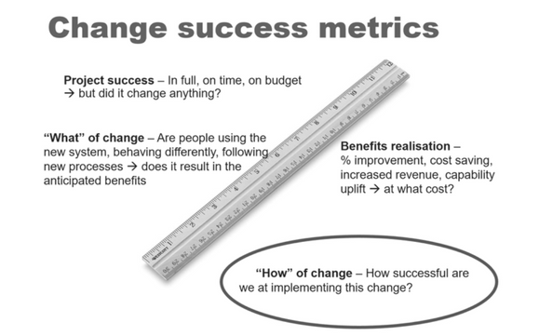
Image source: Dr Jen Frahm
If you’re struggling with measuring the effectiveness of your change management activities, you’re not alone. Yet today’s practitioners face growing pressure to build a measurement strategy into their standard change management framework.
Measuring the people side of change is becoming an expectation and even a requirement in many organisations. Forty percent of Prosci research participants say they must report on change management effectiveness for their projects. Most commonly, they report measurements to project sponsors, general leadership, and project (and program) personnel.
Measuring change management used to be considered elusive and complicated. And although measuring change management can vary from project to project, measurement fundamentals are emerging. Prosci’s extensive research sheds light on how to craft a well-rounded measurement strategy.
To gather insight on change management measurement and metrics, we asked practitioners about their overall experience with measuring change management variables. We also inquired about the frameworks they use to support measurement. The specific questions we asked practitioners in multiple studies over nearly a decade include:
"Did you measure the effectiveness of your change management effort in support of the project?"
"Did you measure whether the change was occurring at the individual level?"
"Did you have to report on change management effectiveness of the project?"
"How did you demonstrate the value-add of applying change management on the project?"
"How did you measure the overall outcome of applying change management?"
The Growing Trend of Change Management and Reporting
Through this Prosci research, trends on how to measure change management effectiveness have emerged. At the highest level, your measurement strategy should assess.
The change management activities you’re tasked with completing
The outcomes of those activities at both the individual and organisational levels
We will explore measurement in three categories: organisational performance, individual performance, and change management performance.
Gaining alignment across stakeholders at the beginning of a project on the measures in each category is essential. The project sponsor, project team, and change management team should collaborate to define which measures are most meaningful for the project, plus establish a cadence of collecting and reviewing data. You should then track those measures throughout the project and adapt the change management approach to ensure expected project results are achieved. The actual measure used in each category is highly project-dependent. However, research participants report using some common metrics.
Measuring Organisational Performance
The first category of measurement is organisational performance. These measures are associated with the project achieving the desired outcomes for the organisation. Organisational performance metrics should answer the question, “Did the initiative deliver what was expected?” Here are some examples from research participants of organisational performance metrics:
- Performance improvements
- Adherence to project plan
- Business and change readiness
- Project KPI measurements
- Benefit realisation and ROI
- Adherence to timeline
- Speed of execution
Measuring Individual Performance
The next category of measurement is individual performance. These measures indicate whether the individuals impacted by the change are progressing through their change journeys. Since the individual is the unit of change, measuring individual progress can be a leading indicator of overall project success.
Based on our research, the individual employee metrics below are commonly used by change management practitioners when demonstrating change management effectiveness. Many of these measures identify where employees are in the change process and how they are progressing. The methods used to obtain these measures include surveys, tests, assessments, observation, and performance evaluations. Individual performance metrics revealed in our research include:
- Adoption metrics
- Usage and utilisation reports
- Compliance and adherence reports
- Proficiency measures
- Employee engagement, buy-in and participation measures
- Employee feedback
- Issue, compliance and error logs
- Help desk calls and requests for support
- Awareness and understanding of the change
- Observations of behavioural change
- Employee readiness assessment results
- Employee satisfaction survey results
- ADKAR® Model surveys
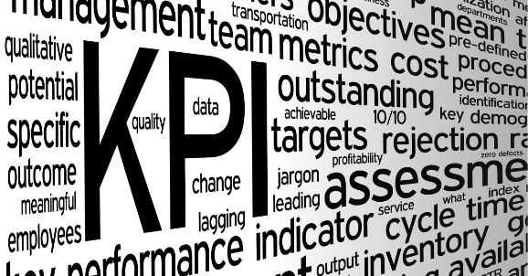
Measuring Change Management Performance
The final category for measurement is change management performance. The metrics in this category are connected to the actual activities carried out by the change management team. While it’s helpful to monitor these activities, the other two outcome-oriented categories of individual and project performance are necessary to determine if the change management activities are successful. Common change management performance measures from research participants include:
Image source: B2T Training
- Tracking change management activities conducted according to plan
- Training tests and effectiveness measures
- Training participation and attendance numbers
- Communication deliveries
- Communication effectiveness
- Performance improvements
- Progress and adherence to plan
- Business and change readiness
- Project KPI measurements
- Benefit realisation and ROI
- Adherence to timeline
- Speed of execution
Change Management Activity Effectiveness
Finally, participants gauged performance by tracking change management activities. Regardless of the type of change, all structured change management initiatives involve these activities, making these metrics useful for any change program.
- Tracking of change management activities conducted according to plan
- Training tests and effectiveness measures
- Training participation and attendance numbers
- Communication deliveries
- Communication effectiveness
Whatever your project, look for ways to measure project performance, individual performance and change management performance so you can thoroughly gauge and report on the effectiveness of your change management activities.
Source: www.prosci.com

Using Google Docs, create and design the following items that will consist of a Change Management toolkit in order to assess feedback and change:
- Pre-change Feedback Form
- Post-change Feedback Form
- Change Management Survey Template

case studies
There are lots of case studies on strategic leadership and change management for you to peruse. Case studies are often used to tell a story, focus on the customer, demonstrate success, leverage a brand, and to stay more in tune with employees and customers.

Using the following case studies to support your presentation. Assess the possible impact of a change on a business from both a positive and negative perspective.
You’ll need to evaluate:
- The impact on the business and employees
- Whether customers service standards were impacted
- The introduction of new technologies
- Profitability (where possible)
- Strategies used to minimise impact


Do not be afraid to state assumptions. Your opinion, along with relevant evidence is valued just as much as the observations by the writer.
Large case studies:
- Successful Strategic Transformation of a “Bricks-and-Mortar” Travel Agency into a “Clicks-and Mortar” Business —Lessons Learned from a Small, Independent Travel Agency in Canada
- Will robots really steal our jobs? An international analysis of the potential long-term impact of automation (Please read Insights and publications from pwc – How will automation impact jobs in New Zealand first, as there’s a link to the Will robots steel our jobs? PDF).
Medium-sized case studies:
- Change Management Case Studies Arcus Consulting Group (No client name has been mentioned in their case studies)
- Bank to the Future: Finding the right path to digital transformation
Short case studies:
- Change Management Case Studies from Strategic Change from Jane Judd
- Change Management Case Studies from Consulting Agencies: Hedgehog Consulting
- Change Management Case Studies from cdl Insight Consulting
- Designing and leading a process improvement programme by Martin Jenkins

